SQL Assingnment 4

Q1. Write a select command that produces the order number, amount and date for all rows in the orders table
ANS---
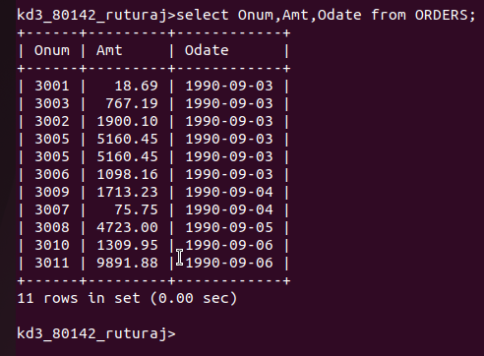

Q2.Write a query that produces all rows from the customers table for which the salesperson number customers table for which the salesperson number is 1001;
Ans----


Q3. Write a query that displays the salespeople table with the columns in the following order city, sname,snum,comm
ANS--

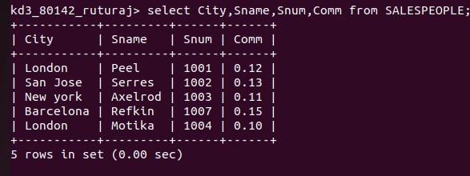

Q4 Write a select command that produces the rating followed by the name of each customers in San Jose
ANS--
