SQL Assignment 5

Q1. write a query that will give you all orders for more than rs.1000
ANS--
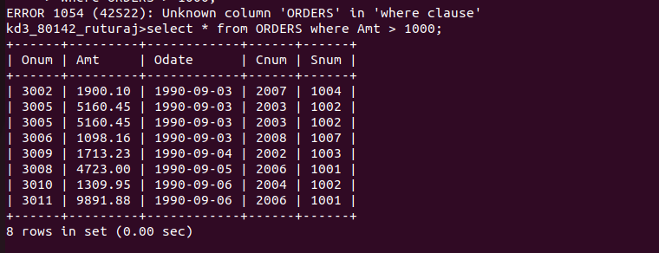

Q2. Write a query that will give you the names and cities of all salespeople in London with a commission above .10
ANS--
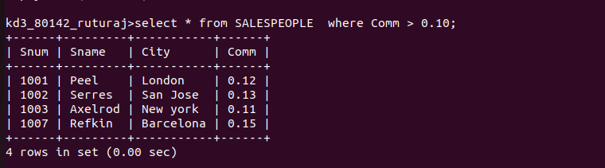

Q3.Write a query on the customers tables whoes output will exclude customers with a rating <=100, unless they are located in rome
ANS--
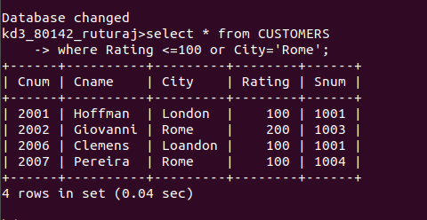

Q4. What will query be output from the follwing query
select * from Orders
where (amt <1000 or NOT (odate =’1990-09-03’ AND Cnum > 2003));

ANS----
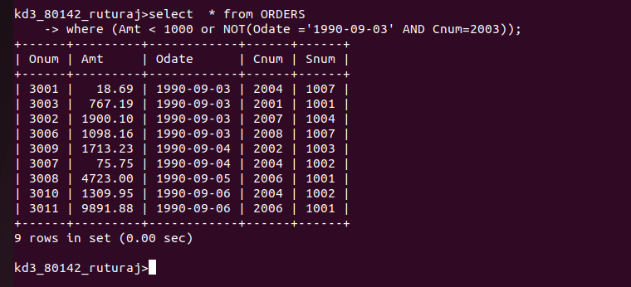
Q5.What will query be output from the follwing query
select * from Orders
where (amt <1000 or Snum >1006)AND Amt>=1500);
ANS----
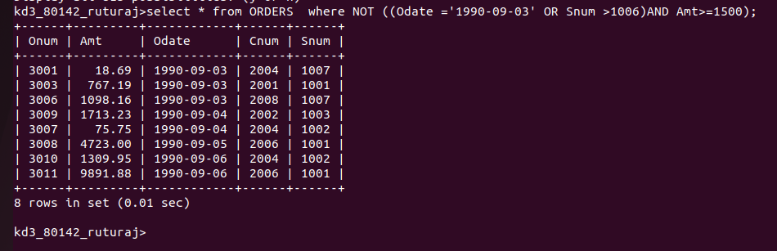

Q5.What will query be output from the follwing query
ANS--
