SQL Assignment No6
Q1.Write two differnt queries that would produce all orders taken on October 3rd,or 4th 1990
ANS---
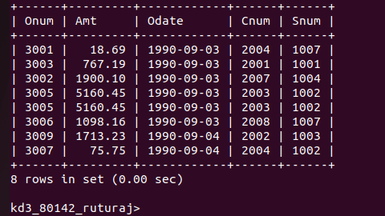

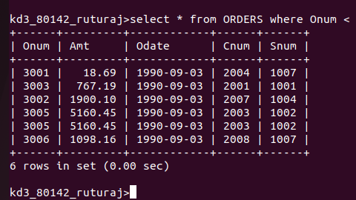

Q2.Write a query that selects all of the customers servied by peel or motika .
ANS---
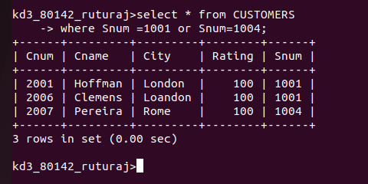

Q3.Write a query that will produce customers whose name begin with a latter from A to G
ANS---
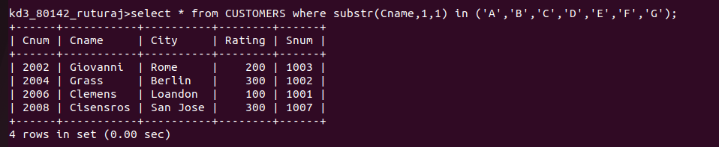
Q4. Write a query that select all cutomers whose names begin with latter c
ANS--

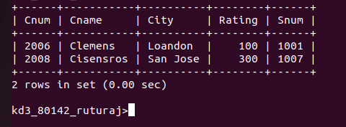

Q5.Write a query that select all orders expect those with zeros or null in amt filed
ANS---

