Assignment NO7

Q1.Write a query that count all odrers for October 3.
ANS---
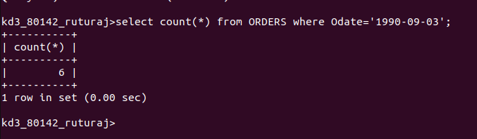

Q2.Write a query that count the numbers of differnt non-null city value in the Customers table
ANS---
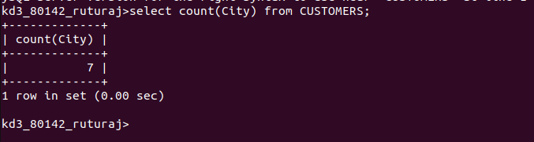

Q3.Write q query that selects ecach Customers samllest order
ANS--
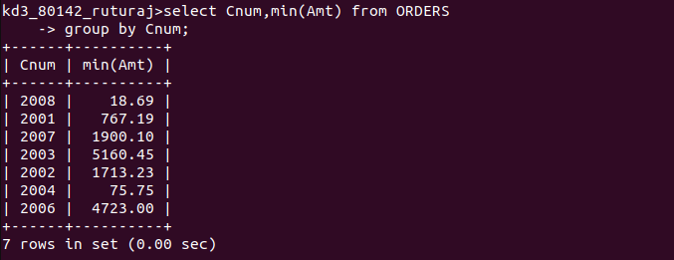

Q5Write a query that select the highset rating in each city
ANS---

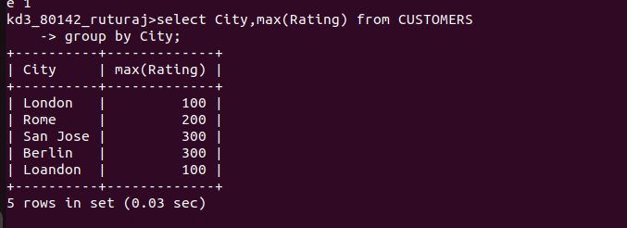

Q4 Write a Query that sekect the frist customers in alphebetical order whose begins
with G
ANS---



Q6.Write a query that counts the number of salespeople registtering orders for each day (If a salespeople has more that one order on a givenday he should br counted only once)
ANS===
