ASSIGNMENT NO 15
1) assume there is a table called multicust with all of the same column definitions as salespeople. write a command that inserts all sales people with more than one customer into this table.
ANS----
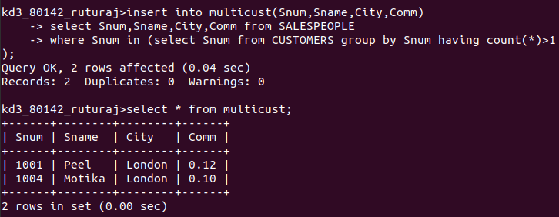

2) write a command that delete all customer with no current orders.
ANS----
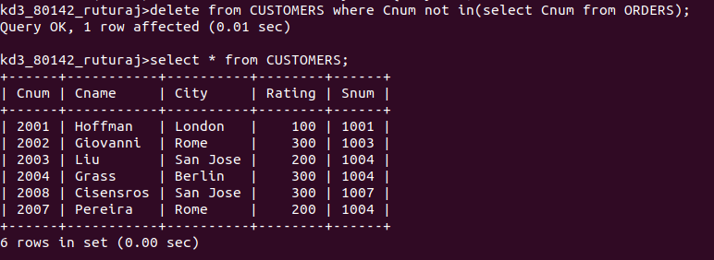
3) write a command that increases by 20% the commission of all salespeople with a total order above Rs 3000
ANS---
