Assignment no12
Q1.Write a query that selects all customers whose rating are equal to greater than
ANY of “Serres”
ANS---
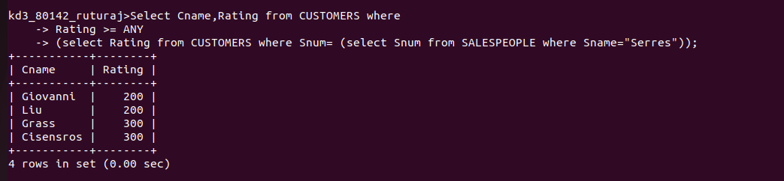

Q2.Write a query using ANY or ALL that will find all salespeople who have no customes located in their city?
ANS--
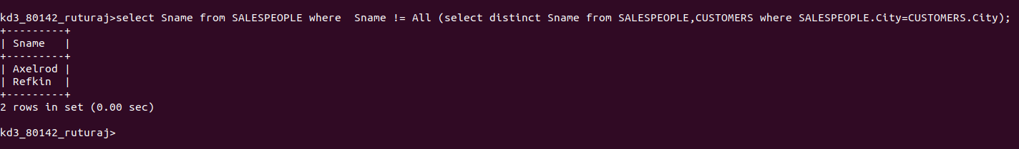

Q3.write a query that selects all orders for amounts greater than any for the customer s in London?
ANS--
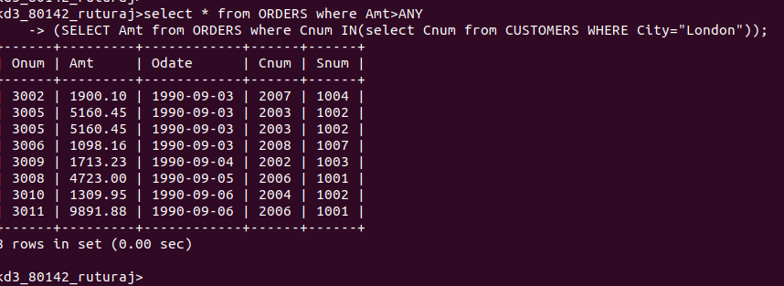

Q4.Write a query using MIN AND MAX
ANS___
