Assignment NO10

Q1.Write a query that prodoces all pairs of salespeople who living in the same city.Exclude combination of salespeople with themselves as well as duplicates rows with the order reversed?
ANS--
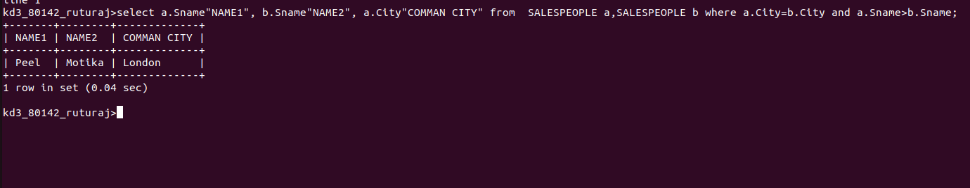

Q2.write a query that produces the same name and cities of customers with same rating as Hoffman?
ANS---

