Assignment-12

USING OPERATOR IN, ANY, ALL.

Q.1 Write a query that selects all customers whose ratings are equal to or grater than any of ‘Serres’.

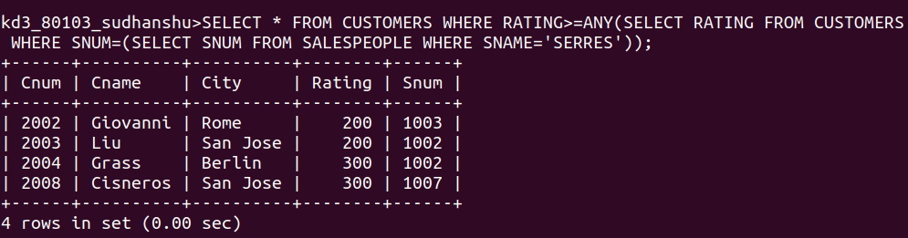

Q.2 Write a query using ANY or ALL that will find all salespeople who have no customers located in their city.

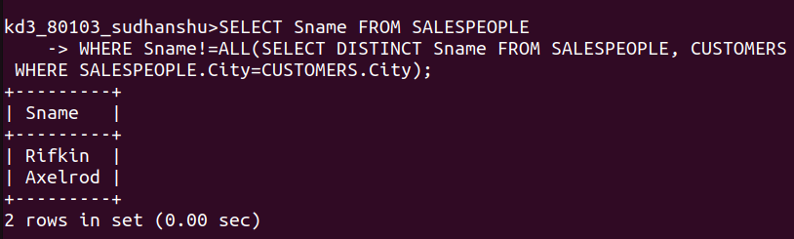

Q.3 Write a query that selects all orders for amount greater than ANY for the customers in ‘London’.

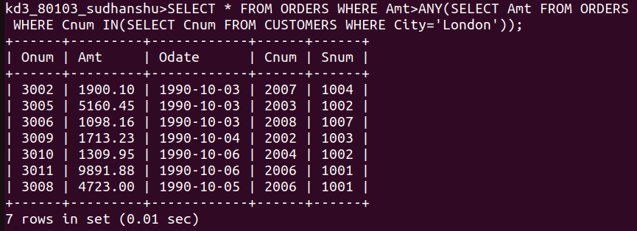

Q.4 Write the above query using MIN or MAX.

