ASSIGNMENT -6

Q. USING SPECIAL OPERATORS IN CONDITIONS

Q1. Two different queries that would produce all orders taken on October 3rd or 4th 1990.

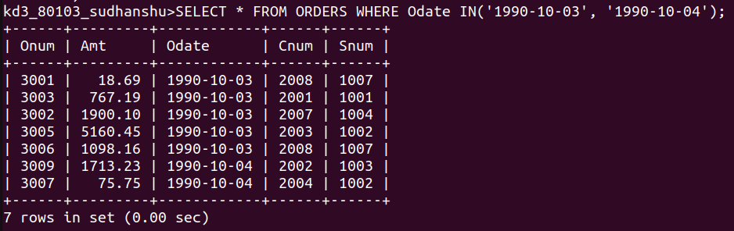

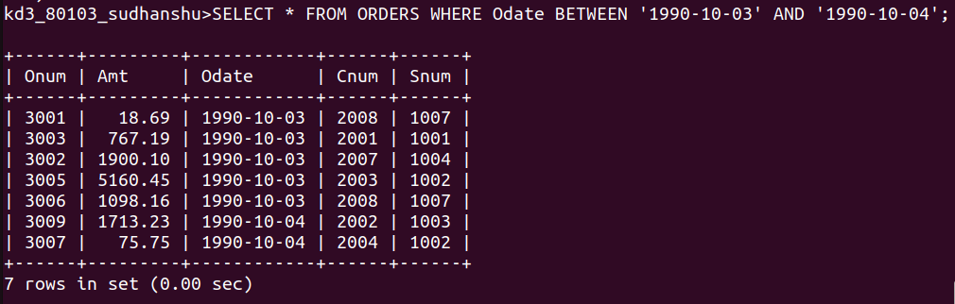

Q2. Write a query that selects all of the customers serviced by Peel or Motika.

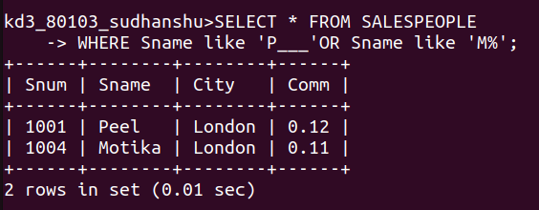

Q3. Write a query that will produce all the customers whose names begin with a letter from ‘A’ to ‘G’.

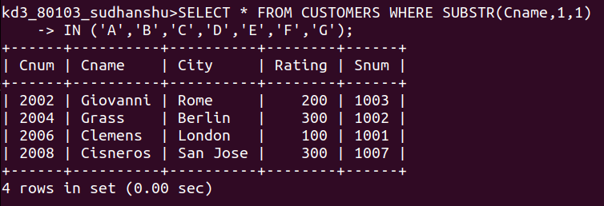
Q4. Write a query that selects all customers whose names begin with the letter ‘C’.

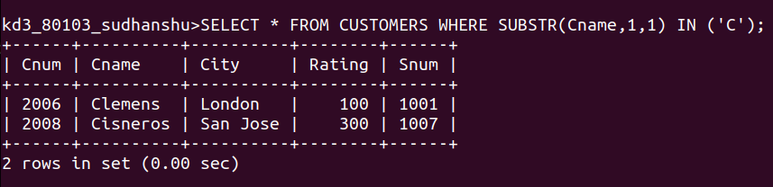
Q5. Write a qury that selects all orders except those with zeros or nulls in the amt field.

