Assignments-8

Q. Formatting Query Output.

Q.1 Assume each salesperson has a 12% commission. Write a query on the orders table that will produce the order number, the salesperon number, and the amount of the salesperson’s commission for that order.
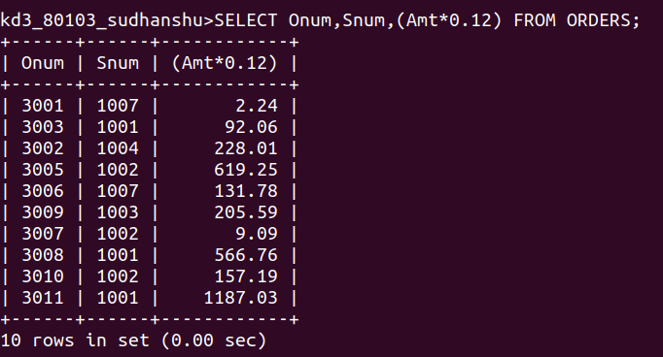

Q.2 Write a query on the Customers table that will find the highest rating in each city.Put the output int this form :

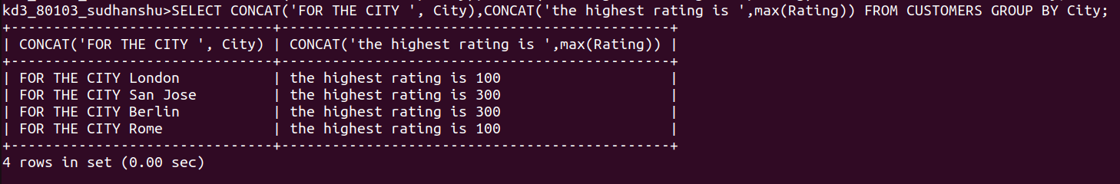

Q3. Write a query that lists customers in descending order of rating. Output the rating field first, followed by the customer’s name and number.

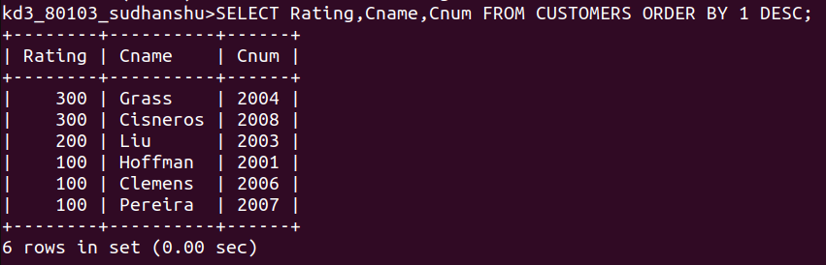

Q4. Write a query that totals the orders for each day and places the results in desc order.

