Assignment-7

Q. SUMMERIZING DATA WITH AGGREGATE FUNCTIONS

Q.1 Write query that counts all orders for October 3.

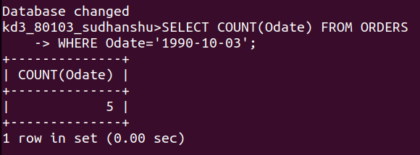

Q.2 Write a query that counts the number of different non_null city values in the customers tables.

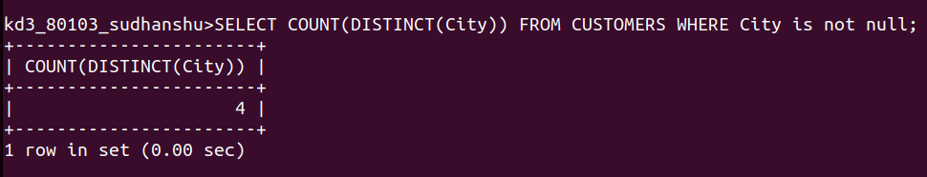

Q.3 Write a query that selects each customer’s smallest order.

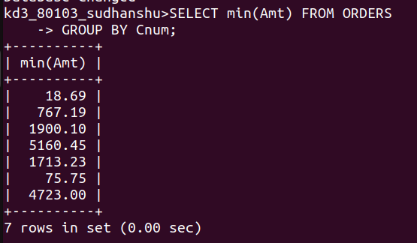

Q4. Write a query that selects the first customer, in alphabetical order, whose name begins with G.

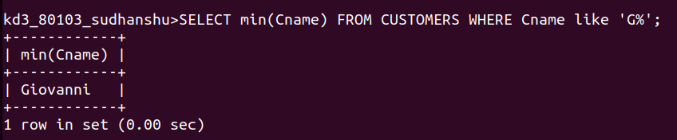

Q5. Write query that selects the highest rating in each city.

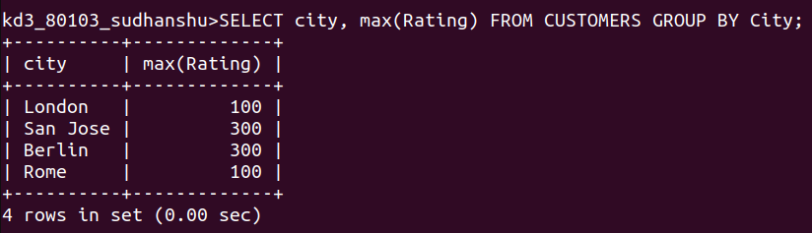

Q.6 Write a qury that counts the number of salespeople registering order foe each day. (If a salespeorson has more than one order a givenday he or she should be counted only once. )

