ASSIGNMENT – 14

ENTERING, DELETING, AND CHANGING FIELD VALUES.

Q.1 Write a cmd that puts the following values, in their given order, into the salespeople table: City San Jose , name – Blanco, Comm – NULL, Cnum – 1100.

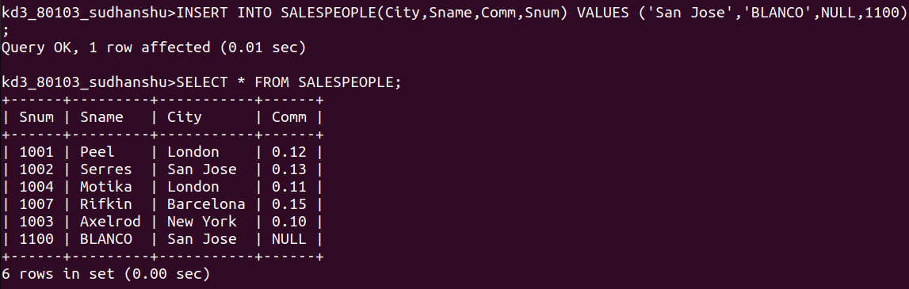

Q.2 Write a cmd that removes all orders from customer Clemens from the Orders table.

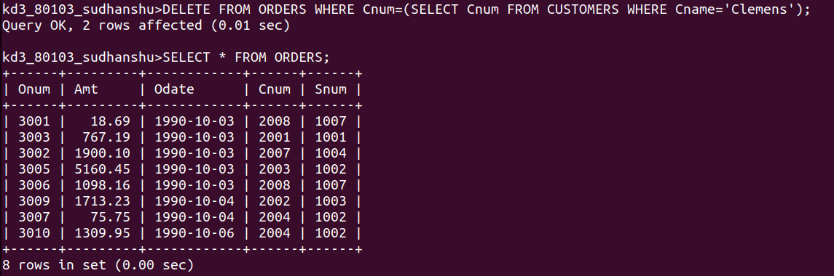

Q.3 Write a cmd that increases the rating of all customers in Rome by 100.

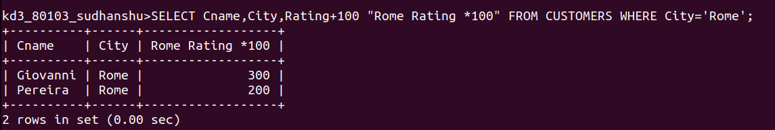

Q.4 Salesperson Serres has left the comapany. Assign her customers to Motika.

