ASSIGNMENT-15

USING SUBQUERIES WITH DML COMMANDS.

Q.1 Assume there is a table calles MULTICAST, with all of the same column definition as salespeople. Write a cmd that inserts all salespeople with more than one customer into this table.

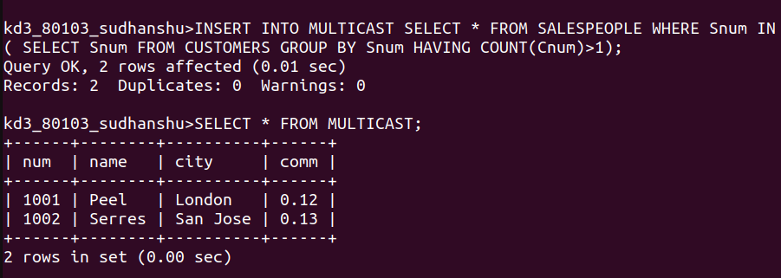

Q.2 Write a cmd that deletes all customers with no currernt orders.

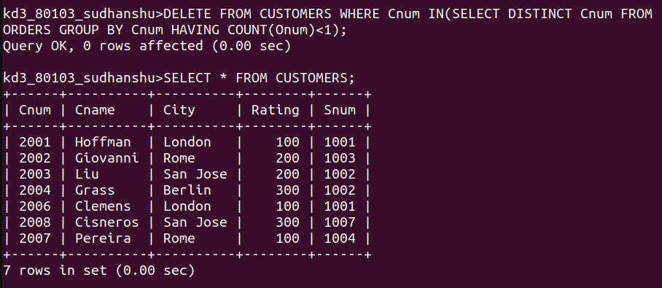

Q.3 Write a cmd that increases by 20% commisions of all the salespeople with total orders above rupees 3000.

