ASSIGNMENTS-9

Q. Querying Multiple Tables at once.

Q.1 Write a that lists each order number followed by the name of the customer who made the order.

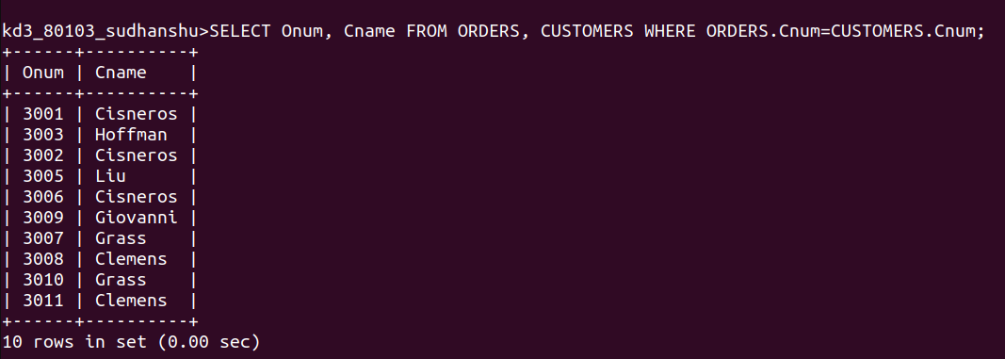
Q.2 Write a that gives the names of both the salesperson and the customer for each order along with the order number.

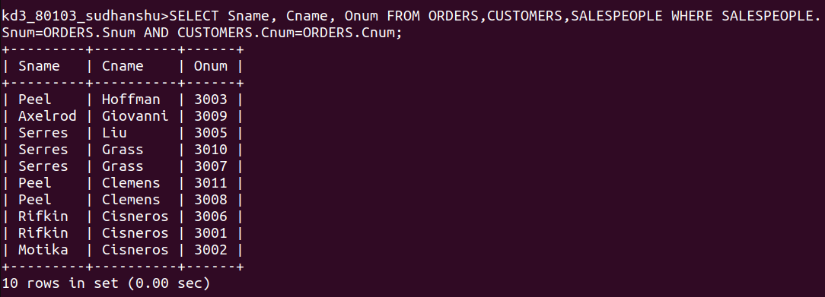
Q.3 Write a query that produces all customers serviced by salespeople with commision above 12%. Output the customer’s name, the salesperson’s name, and the salesperson’s rate of commission.

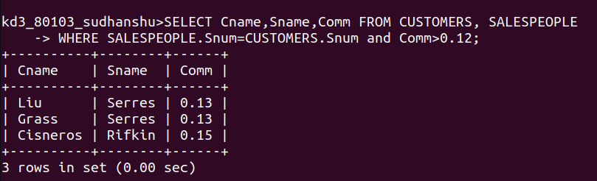

Q.4 Write a query that calculates the amount of the salesperson’s commission on each order by a customers with a rating above 100.

