ASSIGNMENT-13

USING THE UNION CLAUSE.

Q.1 Create a union of two queries that shows the names, cities, and ratings of all customers. Those with rating of 200 or greater will also have the words “High Rating”, While the other will have the word “Slow Rating”.

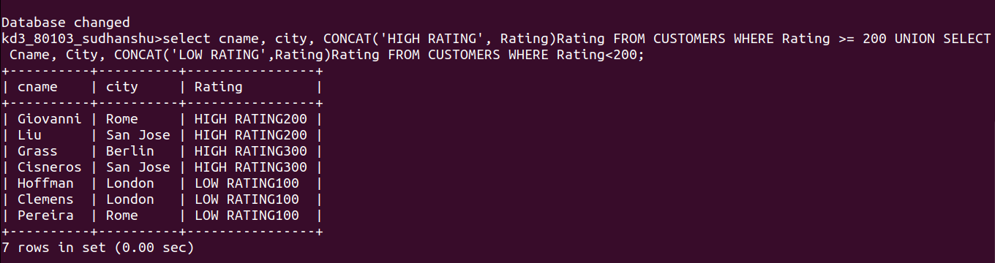
Q.2 Write a cmd that produce the name and number of each salesperson and each customer with more than one current order. Put the result in alphabetical order.

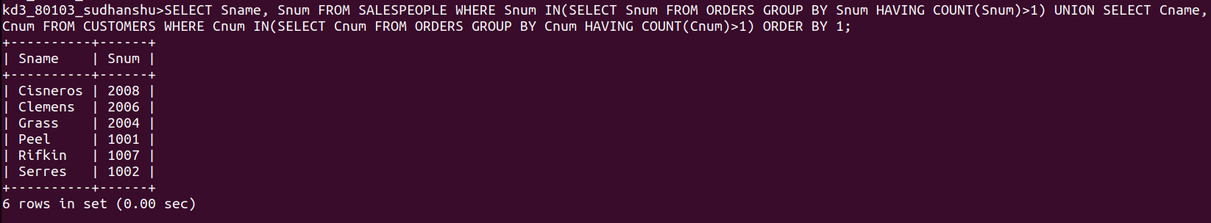
Q.3 Form the UNION of three queries. Have the first select the Snum of all salespeople in Sane Jose; the second, Cnum of all customers in San Jose And third Onum of all order of October 3. Retain duplicates between the last two queries but eliminate any redunduncies between either of them and first.

