ASSIGNMENT – 4

Q. Retrieving Information from Tables.
1) Write a select cmd that producese the order number, amount, and date for all rows in the ORDERS table.
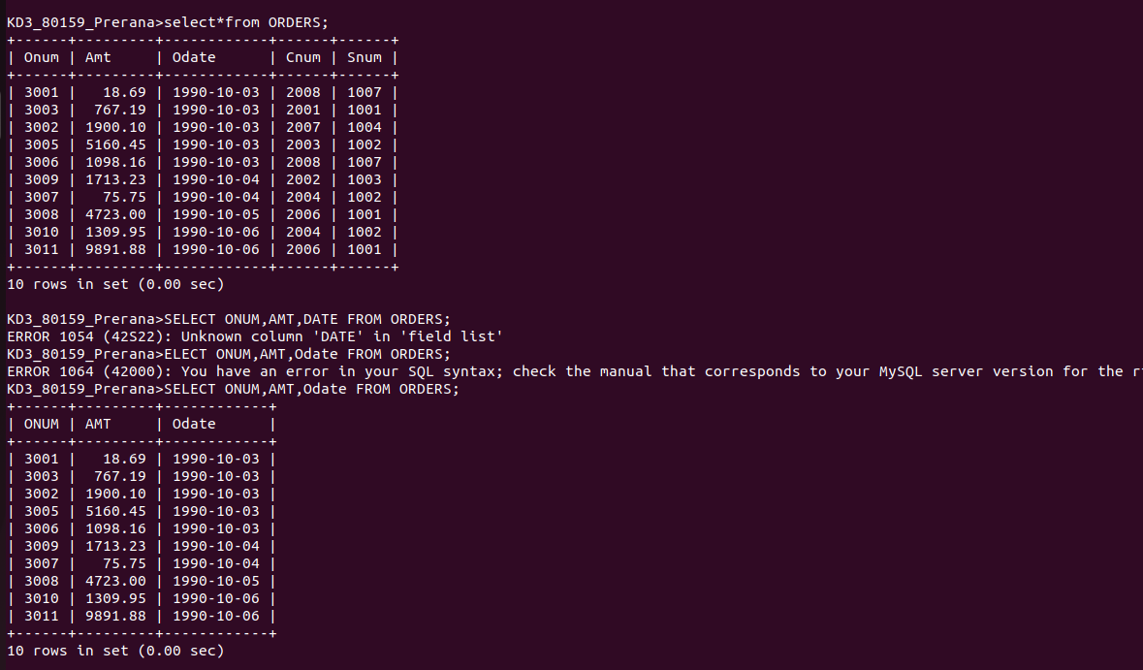

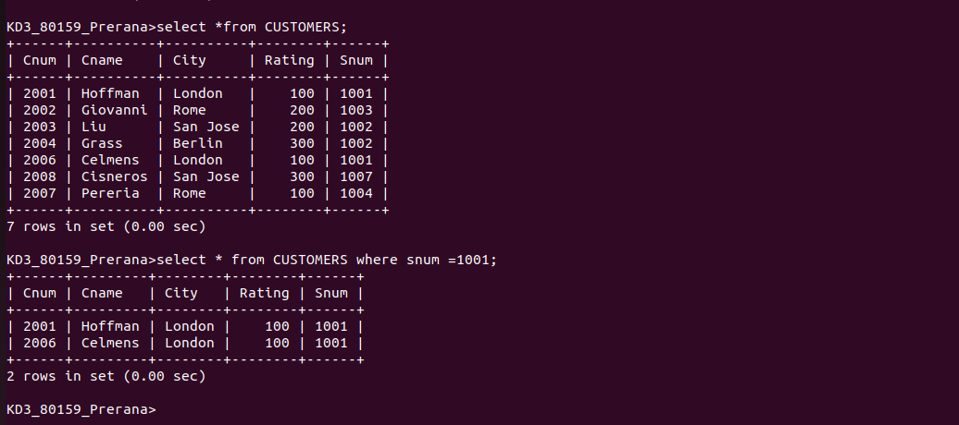
2) Write a query that produces all rows from the CUSTOMERS table for which the saleperson’s number is 1001.

3) Write a query that displays the SALEPEOPLE table with the coloumns in the following order:
city, sname, snum, comm.
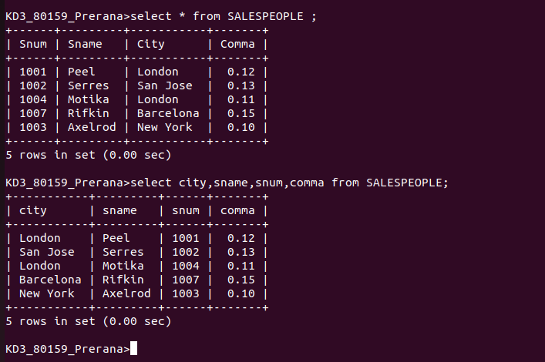

4) Write a select cmd that produces the rating followed by the name of each customer in San Jose.

