SQL ASSIGNMENT – 10

Joining table to itself

Q1 ) Write a query that produces all pairs salespeople who are living in the same city
Ans :

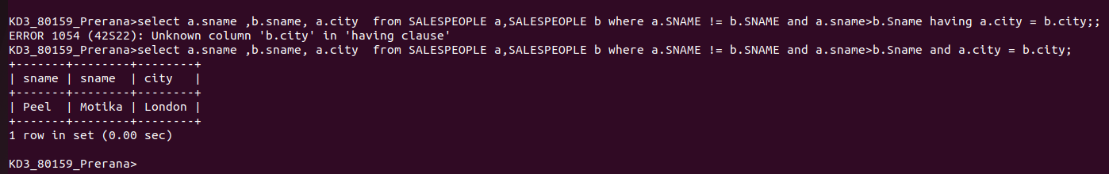

Q2) write query that produce names and queries of all customers with same rating as hoffman
Ans :
