Q1 ) Write a query that counts all orders for October 3.

Q2) Write a query that counts the number of different non-NULL city values in the Customer table.
Ans :


Q3) Write a query that selects each customer’s smallest order.
Ans :




Q4) Write a query that selects the first customer, in alphabetical order, whose name begins with ‘G’.
Ans :

Q5) Write a query that selects the highest rating in each City.
Ans :

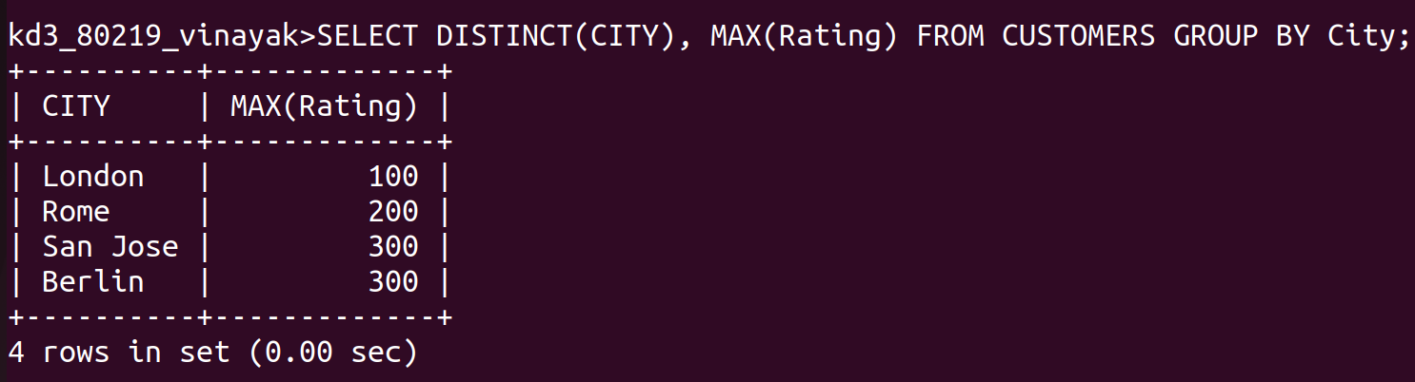


Q6) Write a query that counts the number of Salespeople registering orders for each day.(If a Salesperson has more than one order on a given day, he or she should be counted only once.).

