1 Write two diff queries
by between
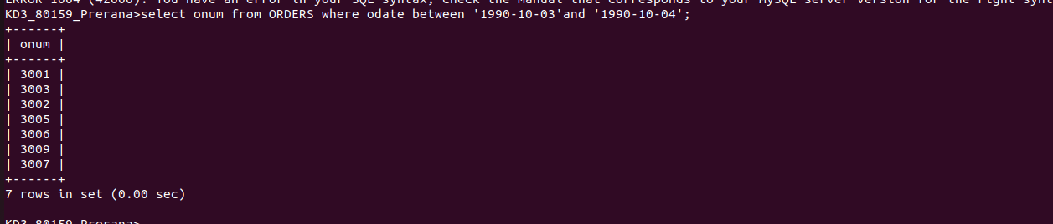

1
by in


2write query that select custmer by services by peel & Monika



3 Query for selectinf cnameThat begins with ‘A%’ & ‘G%’



4.Query for custmer name begin with “c%”
5write query that select custmer except 0 and null


