SQL ASSIGNMENT – 14

Q1 ) Write a command that puts the following values, their given order, into the salespeople table: City San Jose, name - Blanco, comm - NULL, cnum 1100.

Ans :

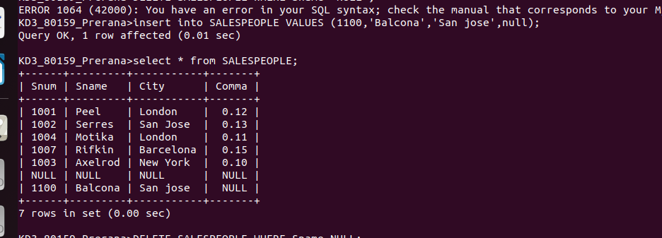

Q2) Write a command that removes all orders from Customer “Clemens” from the Orders table.
Ans :
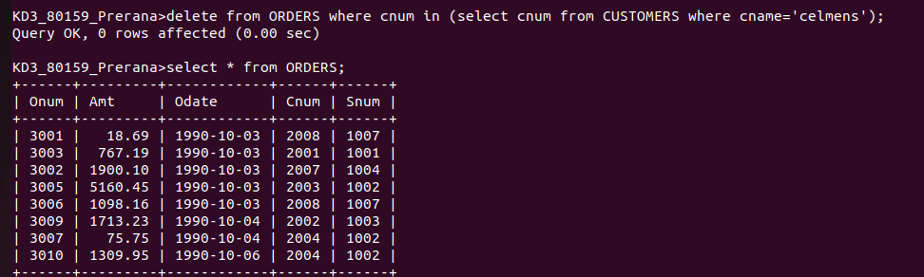

Q3) Write a command that increases the rating of all customers in Rome by 100.
Ans :

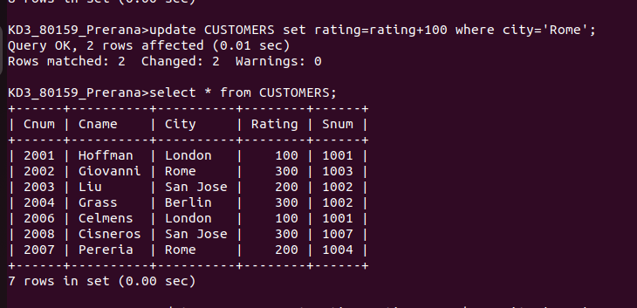
Ans :

4 Salesperson Serres has left the company.Assign her customers to Motika.
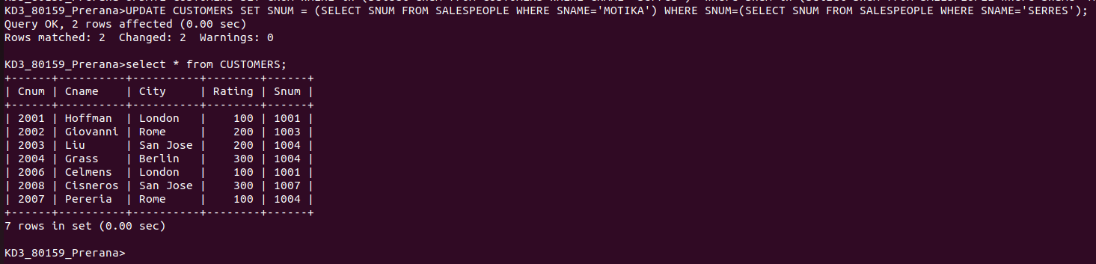
Ans :

