SQL ASSIGNMENT – 14

Q1 ) Assume there is a table called Multicust, with all of the same column definitions as Salespeople, Write a command that inserts all salespeople with ore than one customer into this table.

Ans :

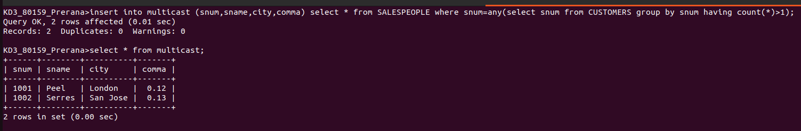

Q2)
Write a command that deletes all customers with no current orders.
Ans :
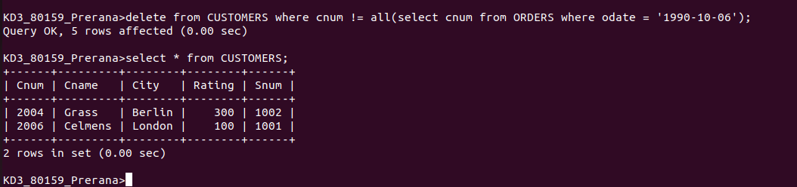

Q3)Write a command that increases by twenty percent the commissions of all salespeople with total orders above Rs. 3,000.
Ans :
