Assignment 03

Q.1 Display hidden files.
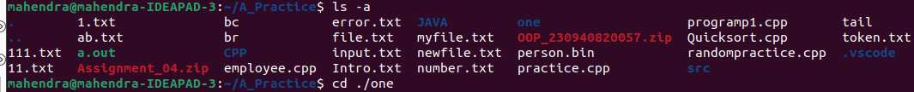

Q.2 rename ‘s/.txt/.htm/’ *.txt

Q.3 ln -s Create symbolic link (shortcut) for a file
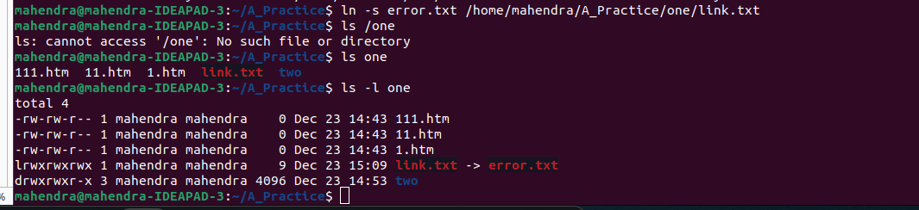

Q.4 ln Create hard link for a file
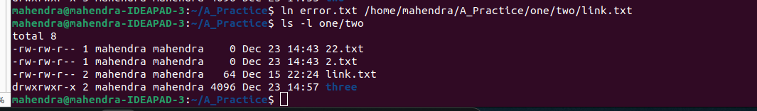

Q.5 stat Display time stamp of the file
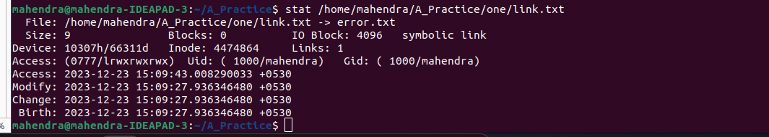

Q.6 touch Change the time stamp of the file
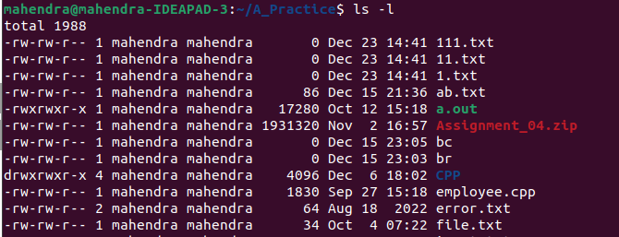

Q.7 touch Create empty file
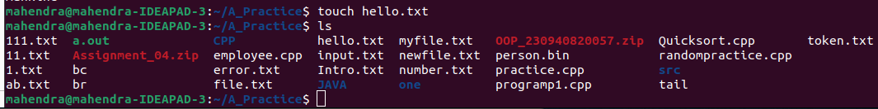

Q. 8 tail Print all lines in a file from fifth line onwards


Q.9 init 0
poweroff
(Shutdown)

Q.10 init 6
reboot
(restart)

Q.11 whoami

Q.12 tty (current terminal)

Q.13 who am i : deprecated command

Q.15 users

Q.16 who
Q.17 grep
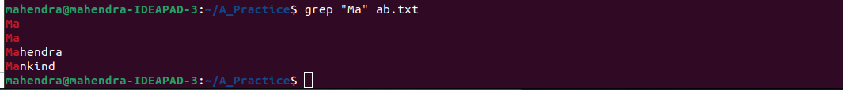
egrep
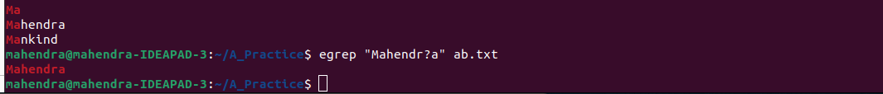
fgrep

Q. 18 chmod ro

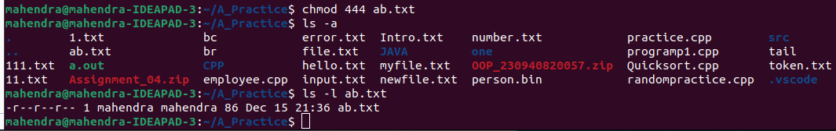
Q.19 chmod rwx

Q.20 wc ab.txt > new.txt

Q.21 who | wc

Q. 22 head -5 ab.txt | tail -5
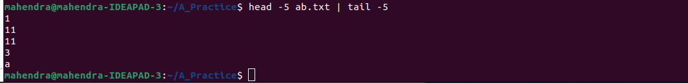

Q. 23 sort text.txt | uniq


Q. 24 who | grep – i “tty[234]”

Q. 25 ls -lhSr
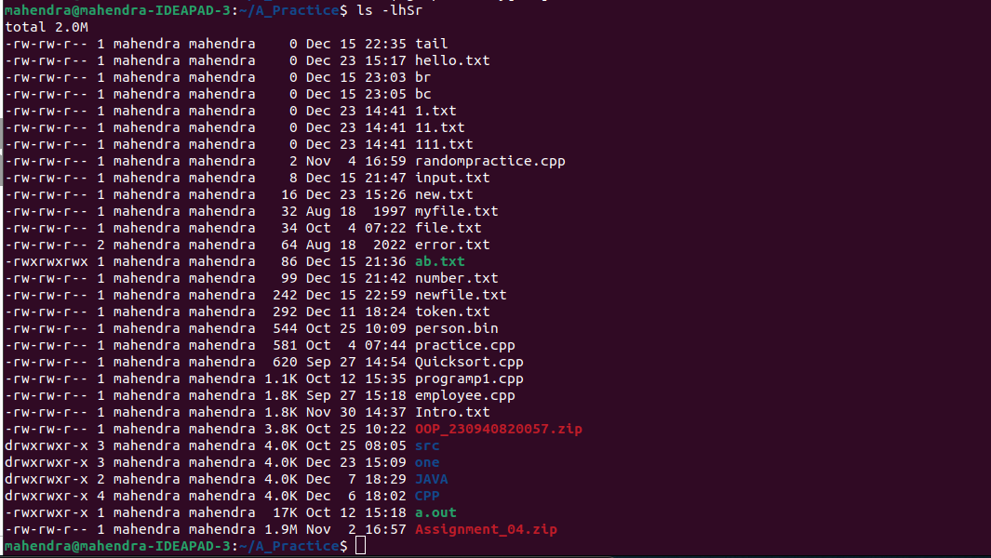

Q. 26 ls | wc -l
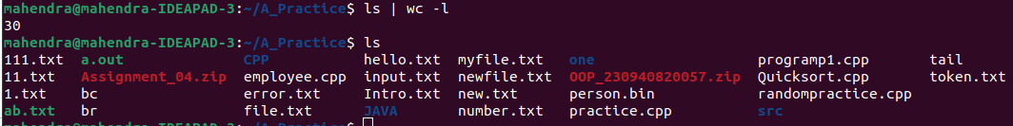

Q. 27 ls -a | grep “^\.”

Q.28 cat text.txt | tr “a-z” “A-Z”


Q. 29 echo “Split Content” | cut -d “ “ -f1

