ASSIGNMENT – 15

1) Assume there is a table called Multicust, with all of the same column definitions as salespeople. Write a command that inserts all salespeople with more than one customers into this table.

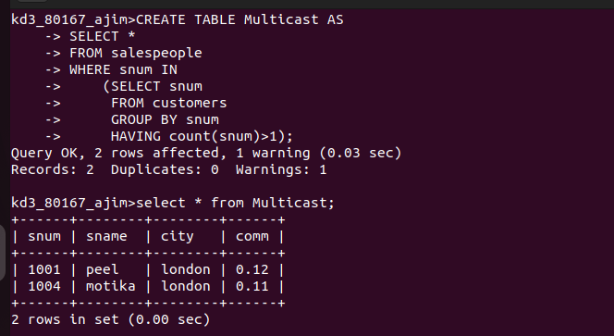
2) Write a command that deletes all customers with no current orders.

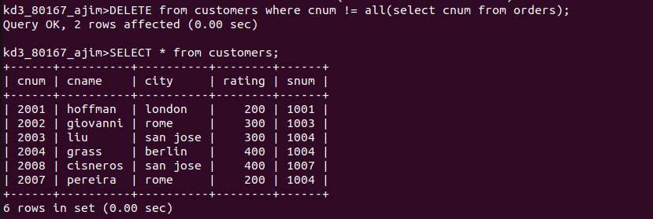

3) Write a command that increases by twenty percent the commissions of all salespeople with total orders above Rs. 3000.

