QUE 1. CREATE A UNION OF TWO QUERIES THAT SHOWS THE NAMES,CITY AND RATING OF ALL CUSTOMERS. THOSE WITH RATING OF 200 OR GREATER WILL HAVE HIGH RATING AND ELSE WILL HAVE LOW RATING

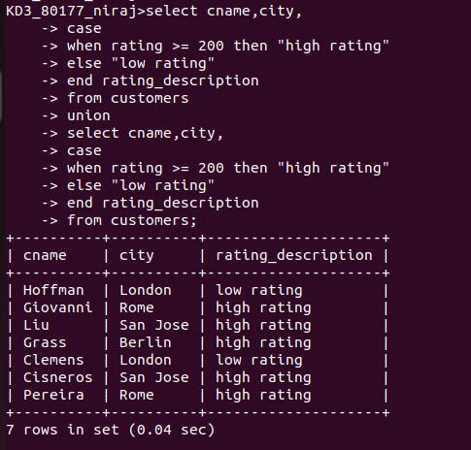

QUE 2. COMMAND THAT PRODUCES THE NAME AND NUMBER OF EACH SALESPERSON AND EACH CUSTOMER WITH MORE THAN ONE CURRENT ORDER.

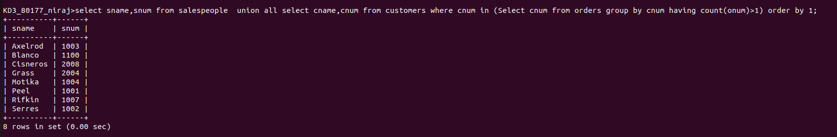

QUE 3. FORM A UNION OF THREE QUERIES, HAVE THE FIRST SELECT THE SUMS OF ALL SALESPEOPLE IN SAN JOSE.

