QUE 1. MULTICAST TABLE COMMAND THAT INSERTS ALL SALESPEOPLE WITH MORE THAN ONE CUSTOMER INTO THIS TABLE

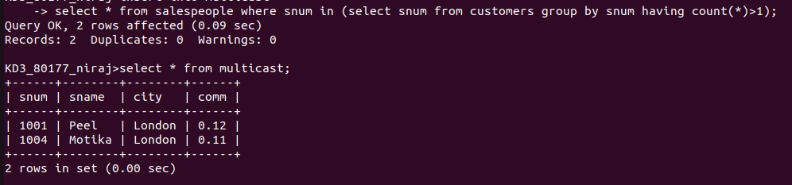

QUE 2. COMMAND THAT DELETES ALL CUSTOMERS WITH NO CURRENT ORDERS

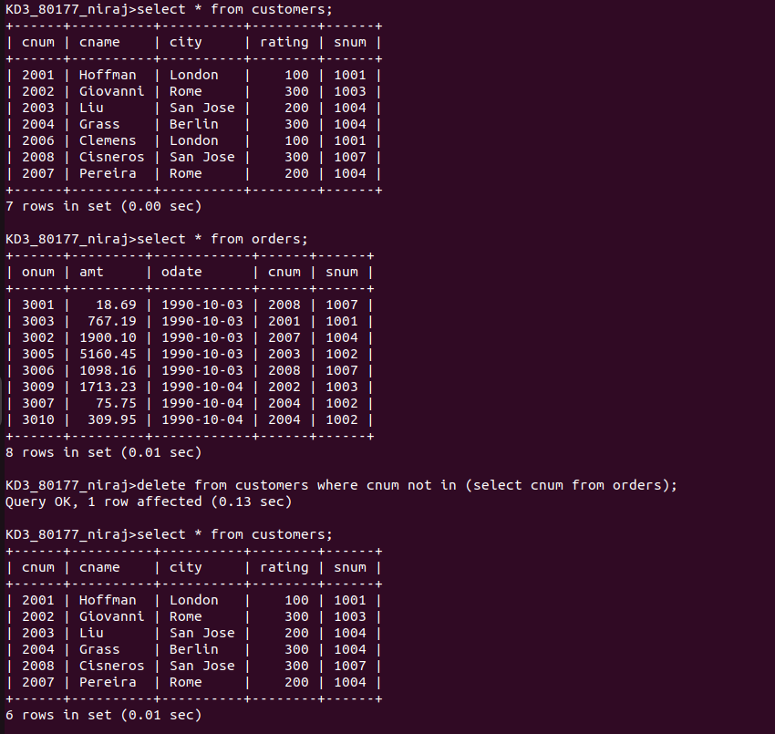

QUE 3. COMMAND THAT INCREASES BY TWENTY PERCENT THE COMMISION OF ALL SALESPEOPLE WITH TOTAL ORDERS ABOVE 3000

