QUE 1: Create table SEMP with following structure

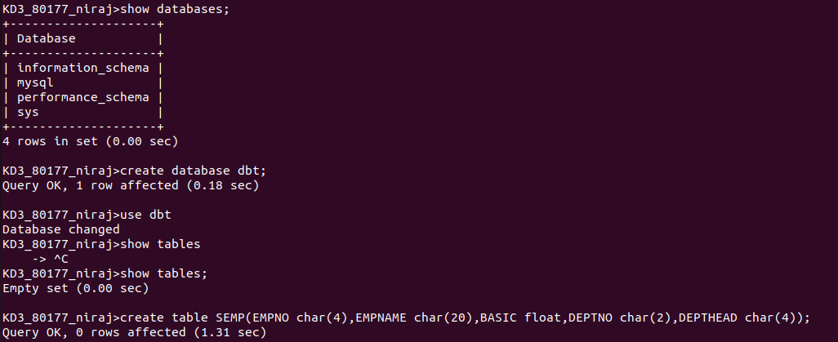

QUE 2: Create table SDEPT with following structure

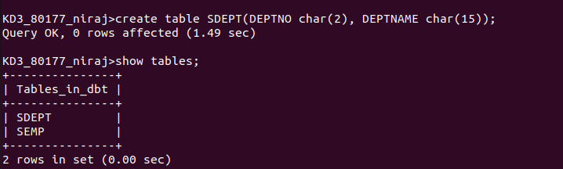

QUE 3: Insert into SDEPT table the following values

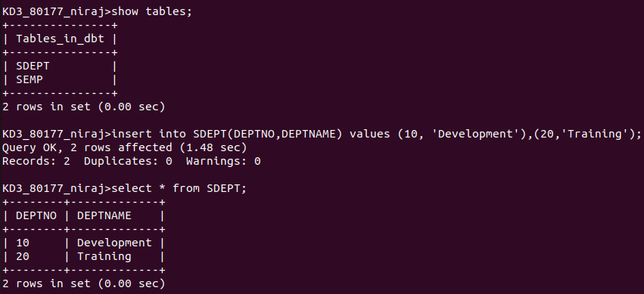

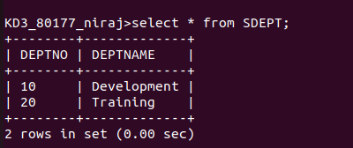

QUE 4: Insert into the semp table the following values

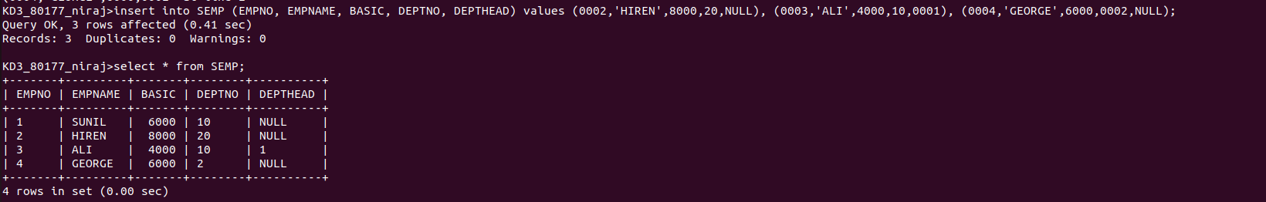

Que 5 S, P, J, SPJ table and question

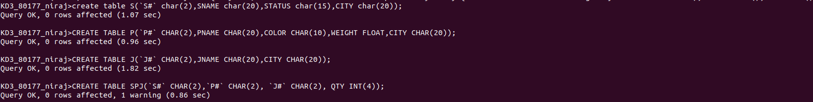

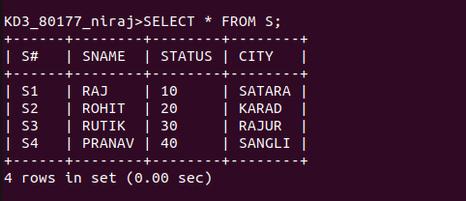

Que 6 Display only the S# and sname fields from the table

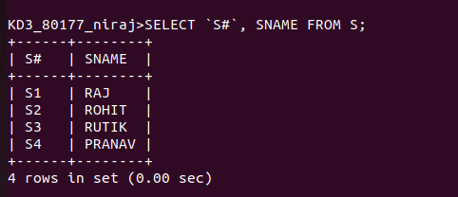

Que 7 display the pname and color from the p table for the city = london

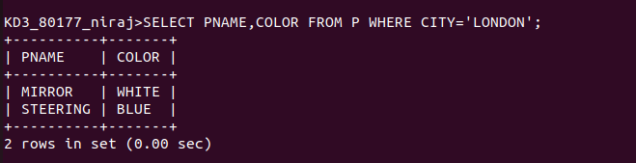

Que 8 display all the suppliers from london

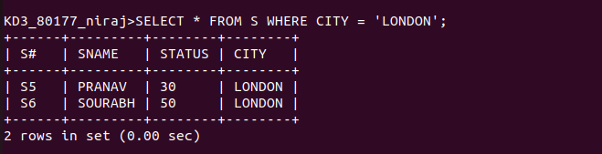

Que 9



Que 10

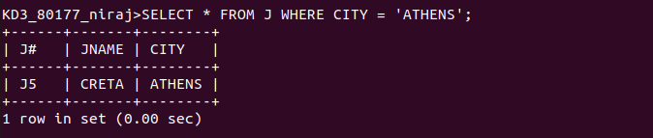

Que 11

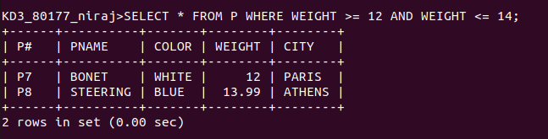

Que 12

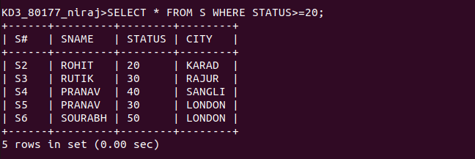

Que 13

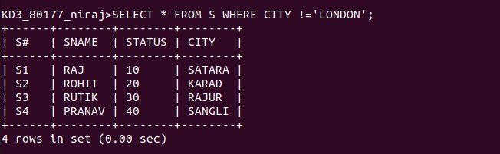

Que 14

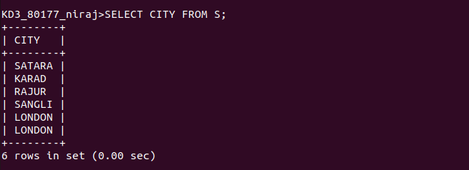

Que 15

