QUE1. WRITE QUERY THAT WOULD PRODUCE ALL ORDERS TAKEN ON OCTOBER 3RD OR 4TH,1990?

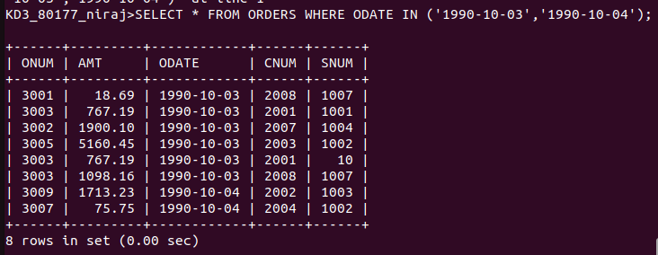
QUE2. WRITE QUERY THAT SELECTS ALL OF THE CUSTOMERS SERVICED BY PEEL OR MOTIKA.
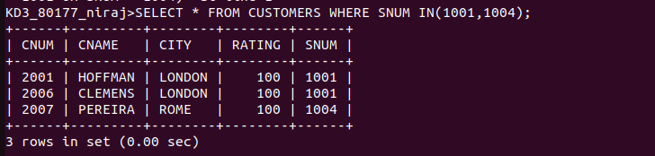
QUE3. NAME STARTING FROM A TO G.
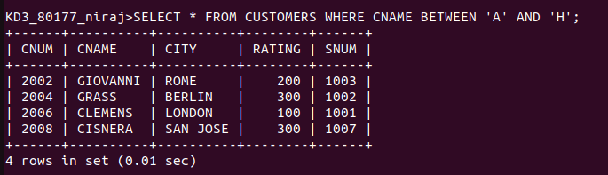
QUE4. NAME STARTING WITH C.

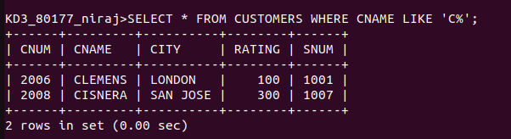
QUE5. ORDERS WITH ZERO OR NULL AMOUNT.
