SQL EXERCISE 3
QUE1. INITIAL LETTER CAPITAL
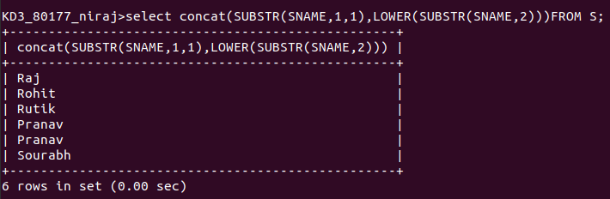
QUE2. NAMES IN UPPER CASE

QUE3. NAMES IN LOWER CASE

QUE 4. 25 PADDING IN LEFT SIDE
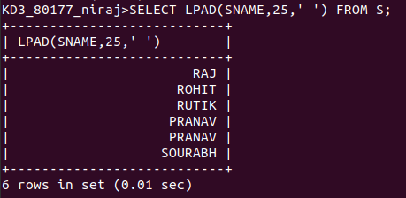

QUE5. LA REPLACING RO

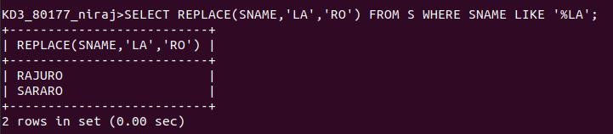
QUE 6. REPLACE L WITH R AND A WITH O


QUE7. LENGTH OF NAMES

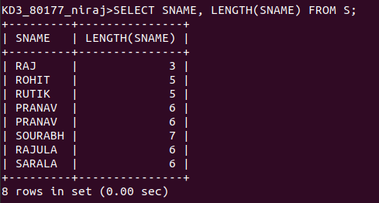

QUE8. BLOKE

