QUE 1. QUERY THAT SELECTS ALL CUSTOMERS WHOSE RATINGS ARE EQUAL TO OR GREATER THAN ANY OF SERRES

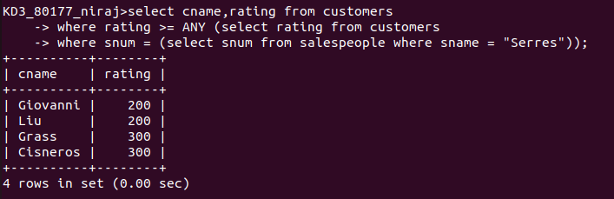
QUE 2. QUERY THAT FIND ALL SALESPEOPLE WHO HAVE NO CUSTOMERS LOCATED IN THEIR CITY

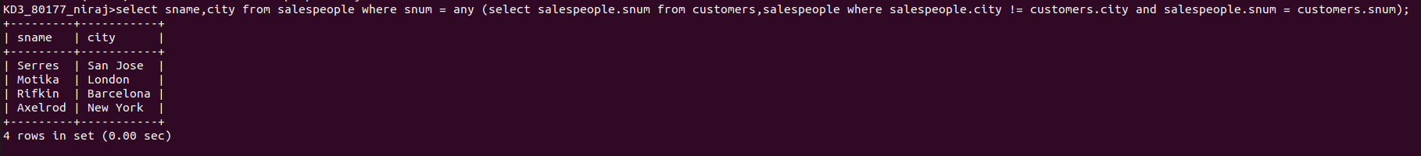

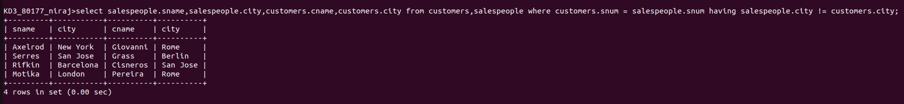
QUE 3. QUERY THAT SELECTS ALL ORDERS FOR AMOUNTS GREATER THAN ANY FOR THE CUSTOMERS IN LONDON

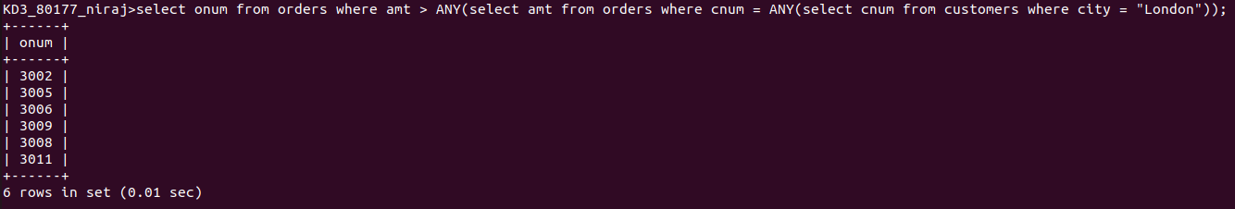
QUE 4. WRITE THE ABOVE USING MIN OR MAX

