QUE 1.QUERY THAT LISTS EACH ORDER NUMBER FOLLOWED BY CUSTOMER NAME WHO MADE ORDER

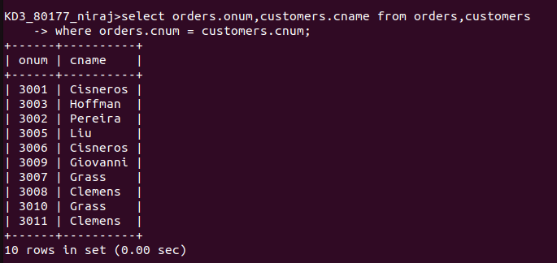
QUE 2. QUERY THAT GIVES NAMES OF BOTH SALESPERSON AND CUSTOMERS FOR EACH ORDER

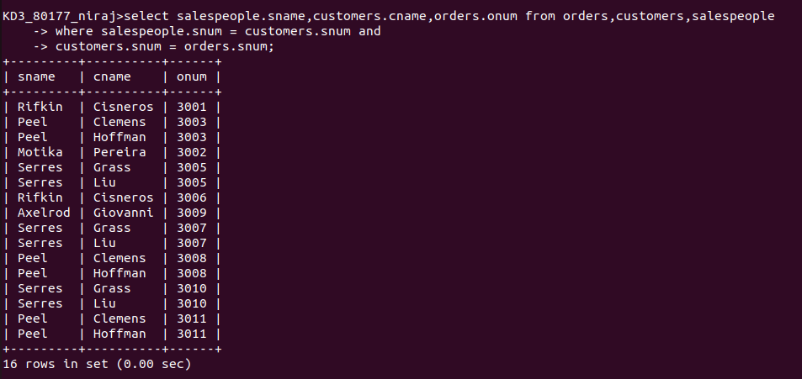
QUE 3. QUERY THAT PRODUCES ALL CUSTOMERS SERVICED BY SALESPEOPLE WITH A COMMISION ABOVE 12%

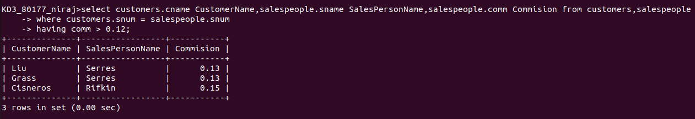
QUE 4. QUERY THAT CALCULATES THE AMOUNT OF THE SALESPERSON COMMISION ON EACH ORDER BY A CUSTOMER WITH A RATING ABOVE 100

