QUE 1. QUERY THAT PRODUCES ALL PAIRS OF SALESPEOPLE WHO ARE LIVING IN SAME CITY.

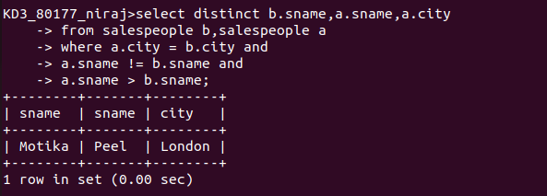
QUE 2. QUERY THAT PRODUCES NAMES AND CITIES OF ALL CUSTOMERS WITH THE SAME RATING AS HOFFMAN

