QUE 1. QUERY THAT USES A SUBQUERY TO OBTAIN ALL ORDERS FOR THE CUSTOMER NAME CISNEROS.

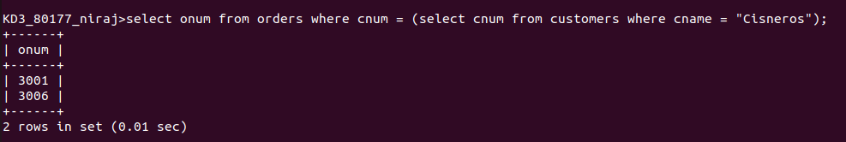
QUE 2. QUERY THAT PRODUCES THE NAMES AND RATINGS OF ALL CUSTOMERS WHO HAVE ABOVE AVERAGE ORDERS

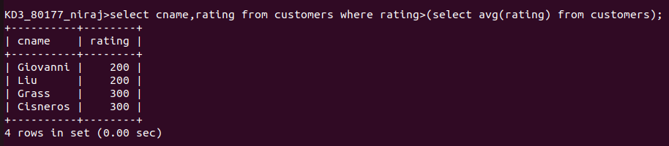
QUE 3. QUERY THAT SELECTS THE TOTAL AMMOUNT IN ORDERS FOR EACH SALESPERSON FOR WHOM THIS TOTAL IS GREATER THAN THE AMOUNT OF LARGEST ORDER IN THE TABLE.

