SQL ASSIGNMENT 8

QUE 1. ASSUME EACH SALESPERSON HAS 12% COMMISION.WRITE A QUERY ON THE ORDERS TABLE THAT WILL PRODUCE THE ORDER NUMBER. SALESPERSON NUMBER, AND THE AMMOUNT OF SALESPERSON COMMISION FOR THAT ORDER

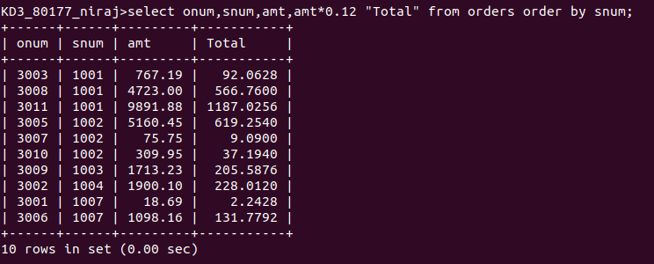
QUE 2. FOR THE CITY (CITY) HIGHEST RATING IS : (RATING)

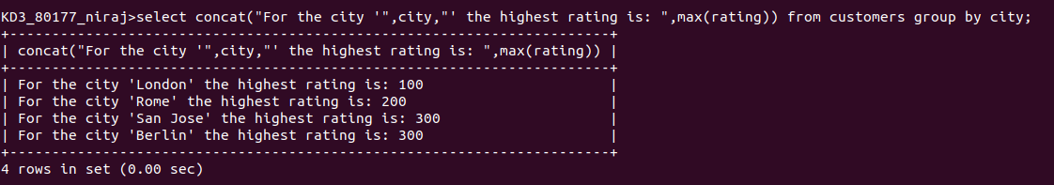
QUE 3. QUERY THAT LISTS CUSTOMERS IN DESC ORDER OF RATING

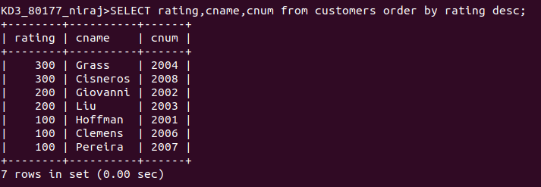

QUE 4. WRITE A QUERY THAT TOTALS THE ORDERS FOR EACH DAY AND PLACES THE
RESULTS IN DESC ORDER

