SQL ASSIGNMENT 14

QUE 1. COMMAND THAT PUTS FOLLOWING VALUES

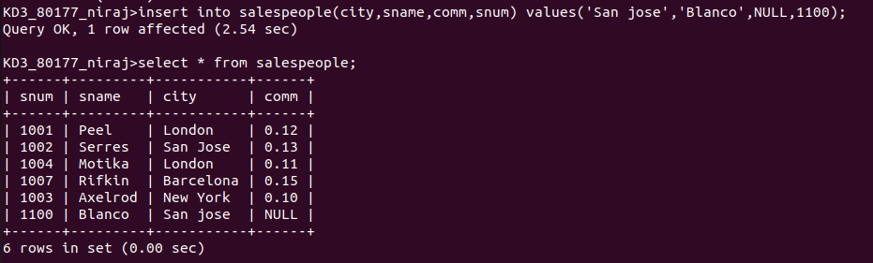
QUE 2. COMMAND THAT REMOVES ALL ORDERS FROM CUSTOMERS CLEMENS

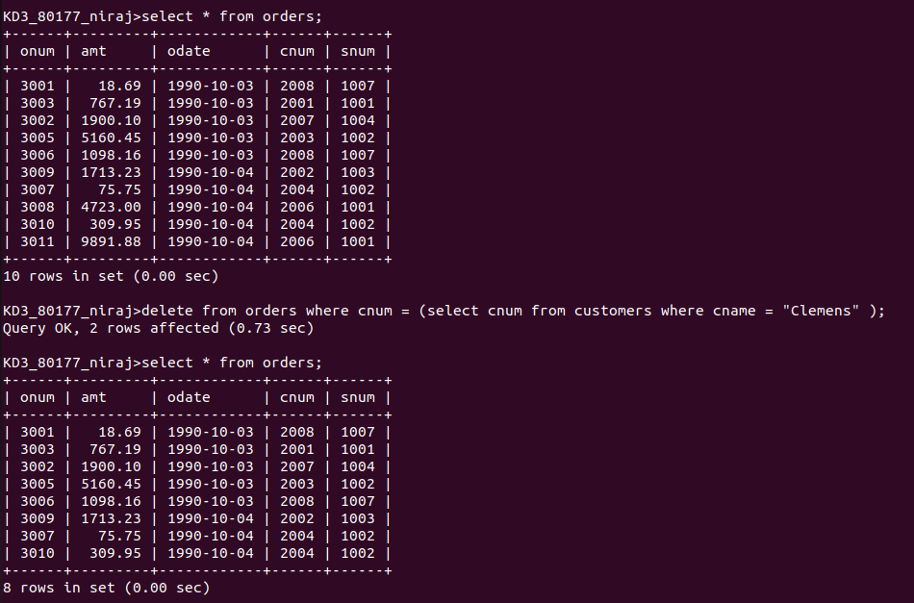

QUE 3. COMMAND THAT INCREASES RATING OF CUSTOMERS IN ROME BY 100

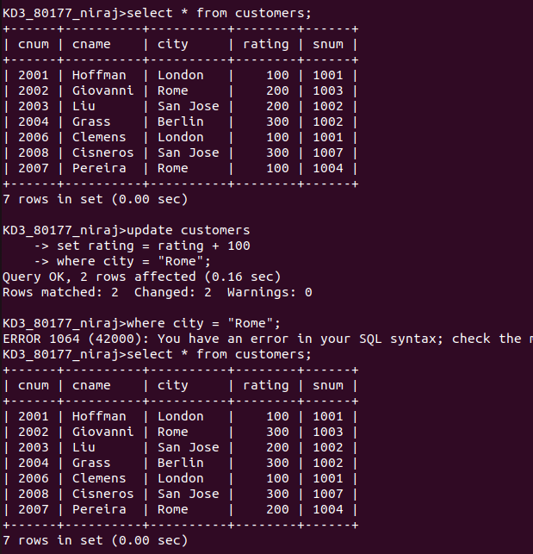

QUE 4. SALESPERSON SERRES HAS LEFT THE COMPANY. ASSIGN CUSTOMERS TO MOTIKA

