SQL ASSIGNMENT 7

QUE 1. COUNT ALL ORDERS FOR OCTOBER 3.

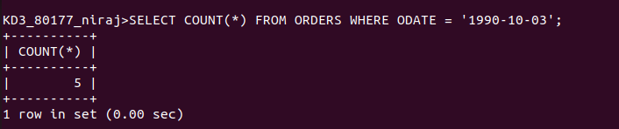
QUE 2. COUNT NUMBER OF NON NULL CITIES IN CUSTOMERS

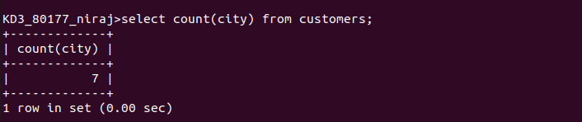
QUE 3. QUERY THAT SELECTS EACH CUSTOMERS SMALLEST ORDER

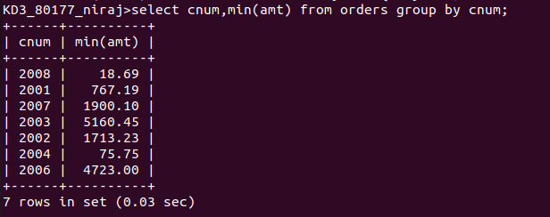
QUE 4. NAME STARTING WITH G AND IN ALPHABETICAL ORDER

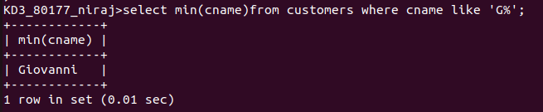

QUE 5. SELECT HIGHEST RATING IN EACH CITY

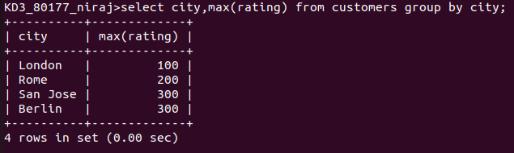
QUE 6. QUERY THAT COUNTS THE NUMBER OF SALESPEOPLE REGISTERING ORDERS FOR EACH DAY

