Assignment 1
Create the following tables with the given structures and insert sample data as specified.

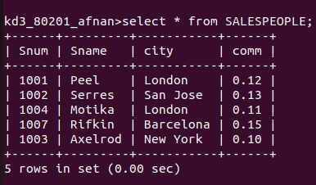
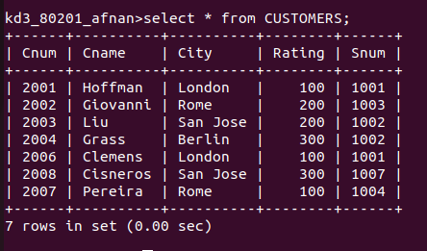
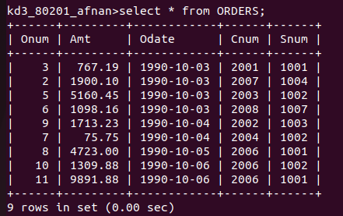
A) Sales People
B) Customers
C) Orders

