Assignment 7
Q1. Write a query that countsl all orders for October 3.

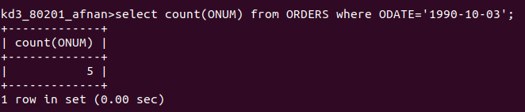

Q2. Write a query that counts the number of different non-NULL city values in the customers table.

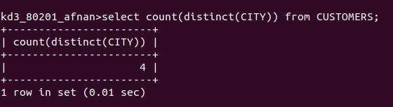

Q3. Write a query that selects each customer’s smallest order.

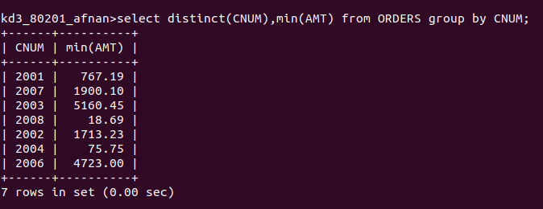

Q4. Write a query that selects first customer in alphabetical order, whose name begins with G.

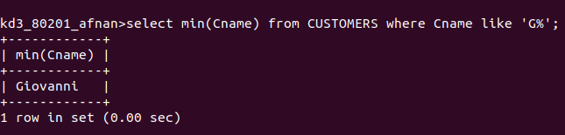

Q5. write a query that selects the highest rating in each city.

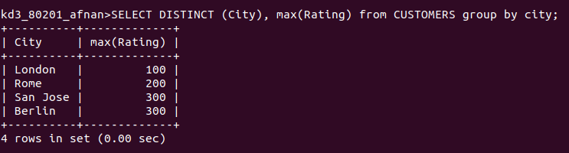

Q6. Write a query that counts the number of salespeople registering orders for each day. (if a salesperson has more than one order on a givenday he or she should be counted only once.)

