SQL Exercise 1
Q1. Create the table SEMP with the following structure:

EMPNO CHAR (4)
EMPNAME CHAR (20)
BASIC FLOAT
DEPTNO CHAR (2)
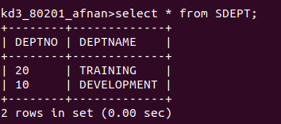
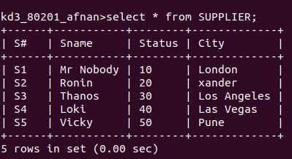
DEPTHEAD CHAR (4)
Q2. Create the table SDEPT with the following structure DEPTNO CHAR (2)
DEPTNAME CHAR (15)
Q3. Insert into the SDEPT table the following values:
10, Develpment
20, Training
Q4. Insert into the SEMP table the following values:-
0001, SUNIL, 6000, 10
0002, HIREN, 8000, 20
0003, ALI, 4000, 10, 0001
0004, GEORGE, 6000, 0002

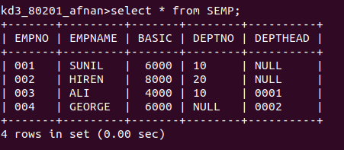
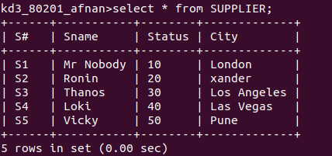
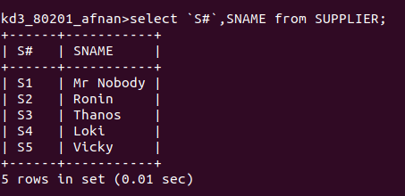
Create S,P,J SPJ tables as specified below and insert a few rows in each table:-
Q5. Display all the data from the S table
Q6 Display only the S# and SNAME fields from the table.
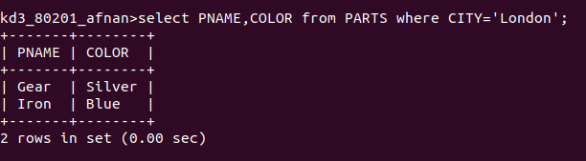
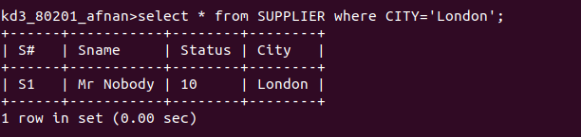
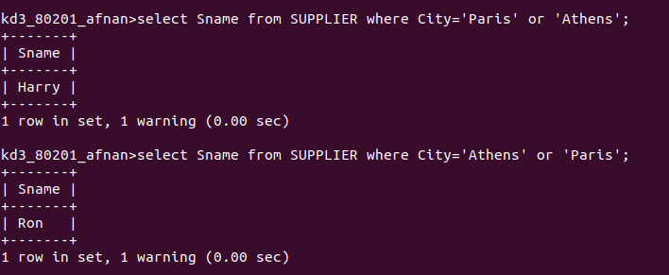
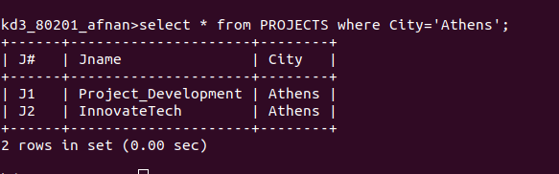
Q7. Display the PNAME and COLOR from the P table for the CITY = “London.
Q8. Display all the suppliers from London.
Q9. Display all the Suppliers from Paris or Athens.
Q10. Display all the projects in Athens.f

Q11. Display all the Partnames with weights between 12 and 14 (inclusive of both).
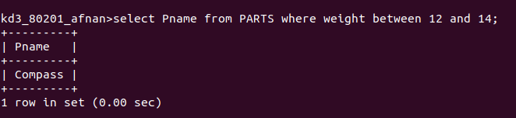
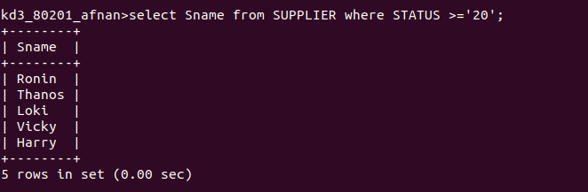
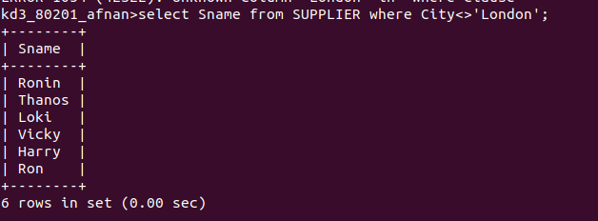
Q12. Display all the Suppliers with a Status greater than or equal to 20;

Q13. Display all the suppliers except the Suppliers from London.

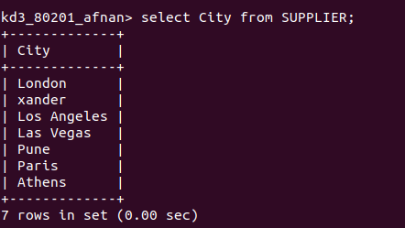
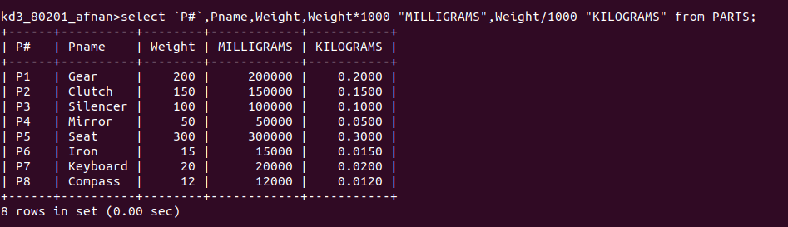
Q14. Display only the Cities from where the Suppliers come from.
Q15. Assuming that the part Weight is in Grams, Display the same in MILLIGRAMS and KILOGRAMS.

