Assignmant-5
Relational and logical operators.
Q1. Write a query that will give you all orders for more than RS. 1000.

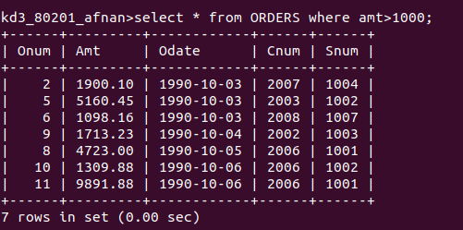

Q2. Write a query that will give you the names and cities of all salespeople in London with a Commision above .10.

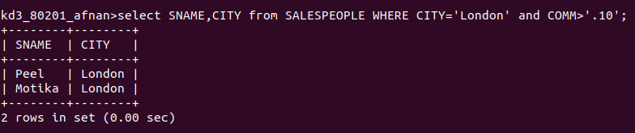
Q3. Write a query on the customers table whose output will exclude all customers with a rating <=100, unless they are located in Rome.

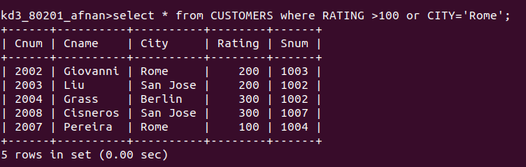

Q4. What will be the output from the following query
Select * from orders
where (amt < 1000 OR NOT (Odate =’1990-10-03’ AND Cnum > 2003));

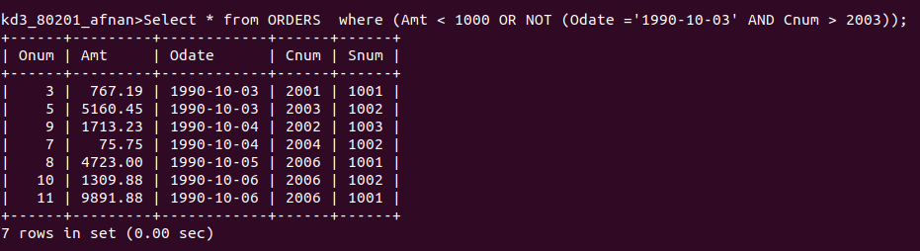

Q5.what will be the output of the following query?
Select * from Orders Where NOT ((Odate = ‘1990-10-03’ OR Snum > 1006) AND amt >= 1500);

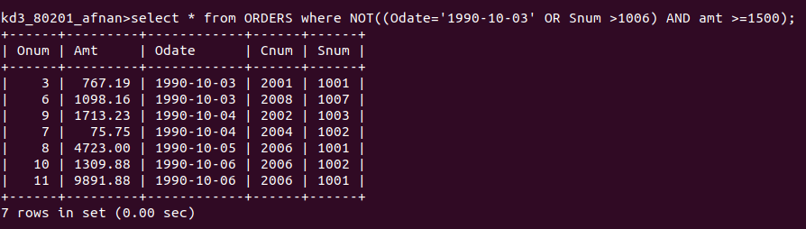
Q6. what is a simpler way to write this query?

Select snum, sname, city, comm From Salespoeple where (comm > .12 OR comm < .14);
