Assignment 15
Q1. Assume there is a table called multicust, with all the same column definition as salespeople. Write a command that inserts all salespoeple with more than one customers into this table

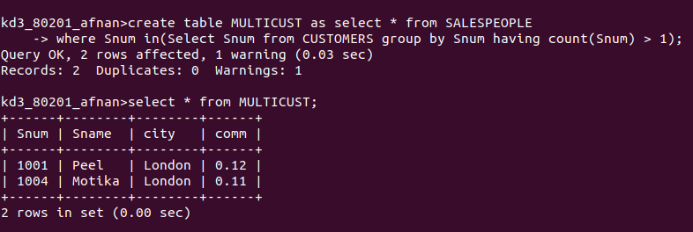

Q2. Write a command that deletes all customers with no current orders.
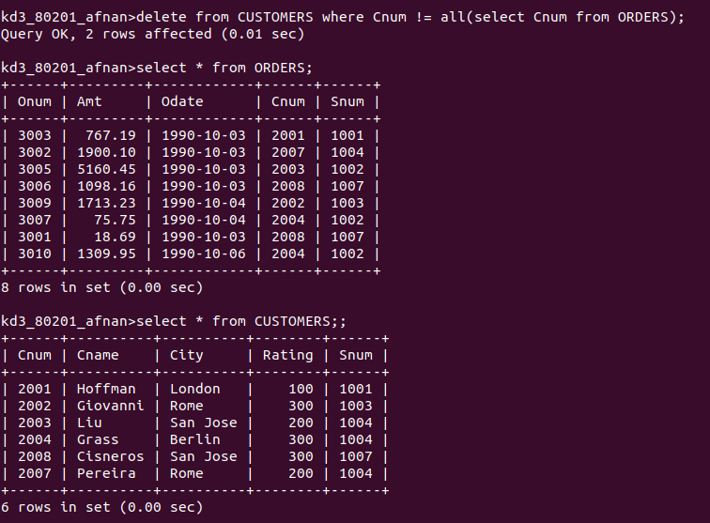

Q3. Write a command that increases by twenty percent the commissions of all salespeople with total orders above Rs. 3000

