Assignement 12
Q1. Write a query that selects all customers whose ratings are equal to or greater than ANY of serres.

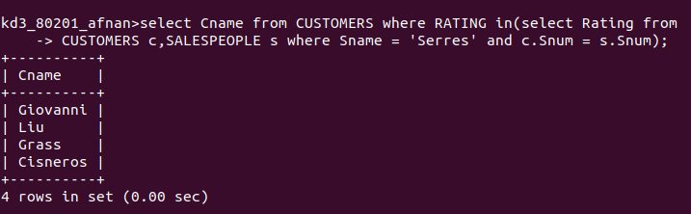

Q2. Write a query using ANY or ALL that will find salespeople who have no customers located in their city.

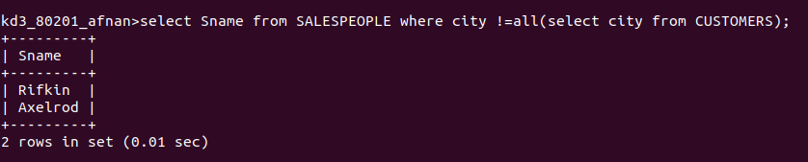

Q3 Write a query that selects all orders for amounts greater than any for the customers in london.
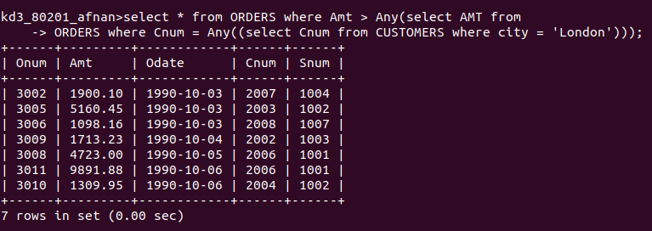

Q4. write the above query using MIN or MAX

