Assignment 14

Q1. Write a command that puts the following values in their given order, into the salespeople table, City -San Jose, Name – Blanco, Comm – NULL Snum-1100

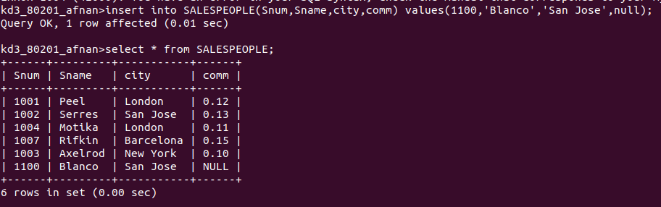

Q2. Write a command that removes all orders from customers Clemens from the Orders table.

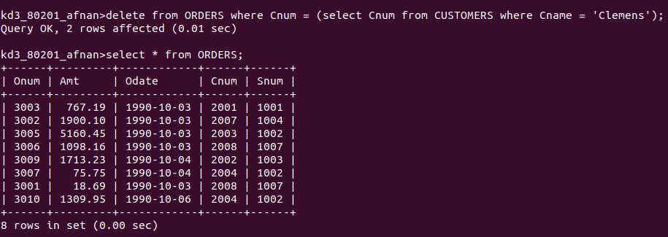

Q3. Write a command that increases the rating of all customers in Rome by 100.
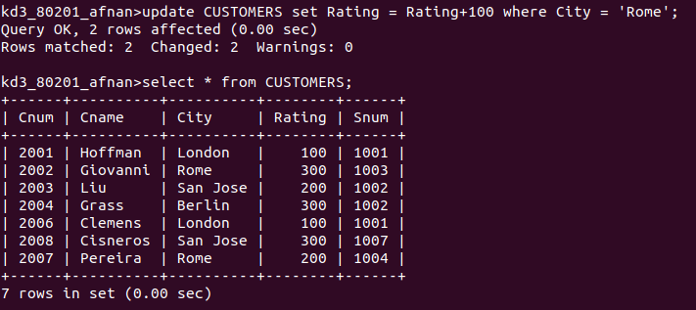

Q4. Salesperson Serres has left the company. Assign her customers to Motika.
