Mongodb Assignment

Q6. View list of available databases

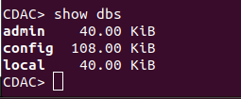

Q7. Create a new database named CDAC and connect to it

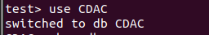

Q8. View list of available collections in CDAC database

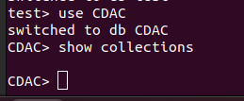

Q9. Create a new collection by the name of LIBRARY

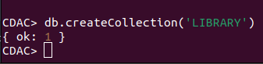

Q10.Insert the following document in the LIBRARY collection:-
title:'MongoDB programming', author:'Sameer', likes:100

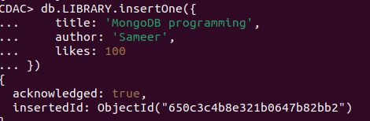

Q11. View the recently inserted document and note the _id field

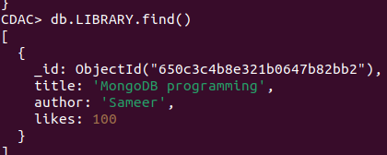

Q12. Insert another document in the LIBRARY collection as follows:-
title:'MySQL programming', authors:['Jack','Jill'], likes:200

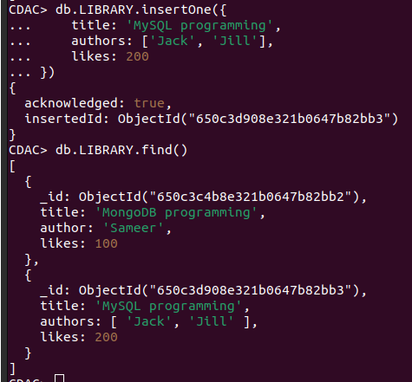

13. View the inserted documents

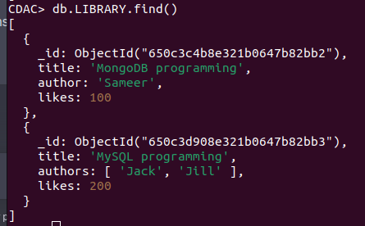

Q14. View only the first inserted document

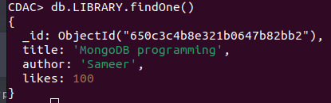

Q15. View the documents using the pretty() method

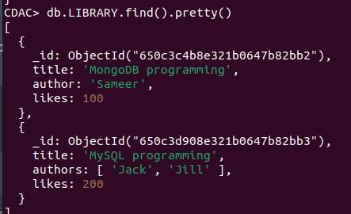

Q16. Update the document where author name = Sameer and change it to Sameer Dehadrai

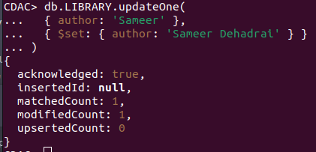

Q17. Delete all documents that have 100 likes

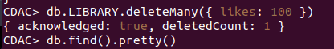

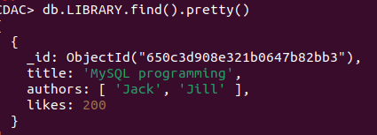

Q18. Drop the LIBRARY collection

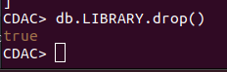

Q19. Drop the CDAC database
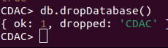

Q20. Exit from MongoDB shell

Q21. Stop MongoDB server

