MongoDB Assignment

1. Install MongoDB database server
2. Create a directory/folder to store MongoDB datafiles
3. Set necessary path environment variable
4. Startup MongoDB database
5. Connect to MongoDB database through the MongoDB shell command line interface
6. View list of available databases.
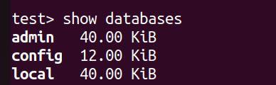

7. Create a new database named CDAC and connect to it.

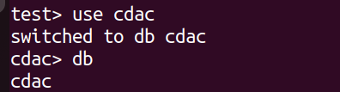

8.View list of available collections in CDAC database
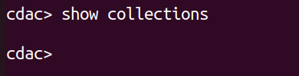

9.Create a new collection by the name of LIBRARY.
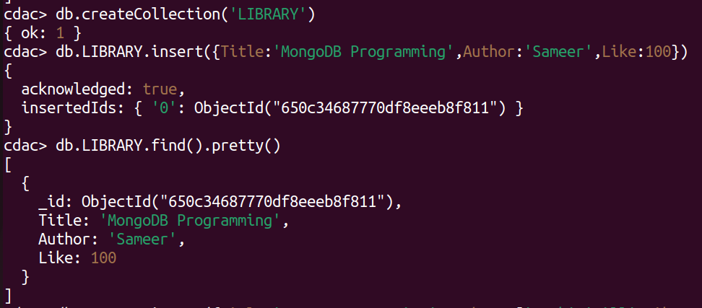

10.Insert the following document in the LIBRARY collection:-
title:'MongoDB programming', author:'Sameer', likes:100 .

11. Insert another document in the LIBRARY collection as follows:-
title:'MySQL programming', authors:['Jack','Jill'], likes:200.
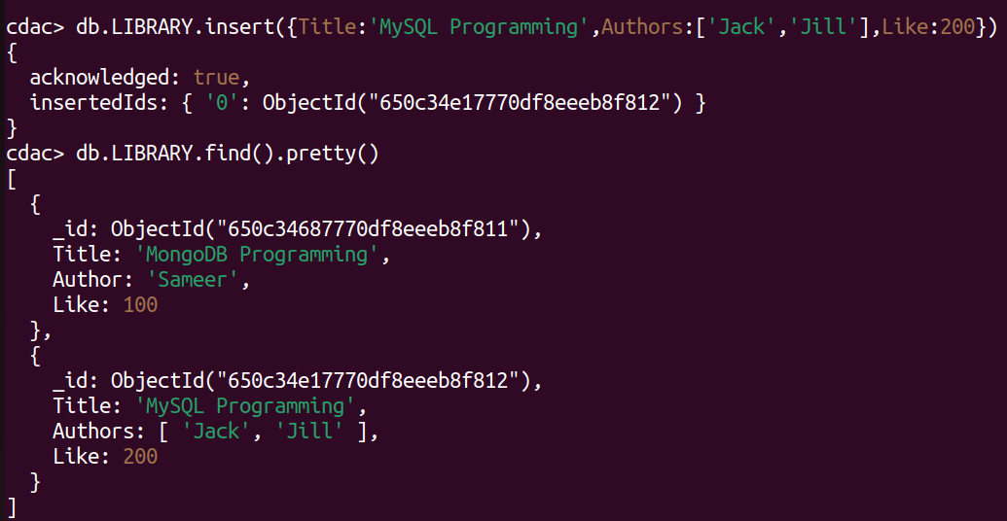

12.View the inserted documents.

13. View only the first inserted document.
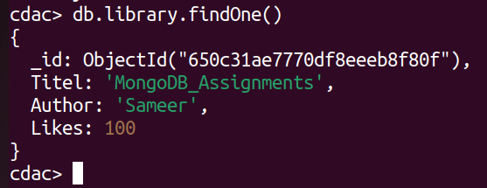

14. View the documents using the pretty() method.

15. Update the document where author name = Sameer and change it to Sameer Dehadrai.

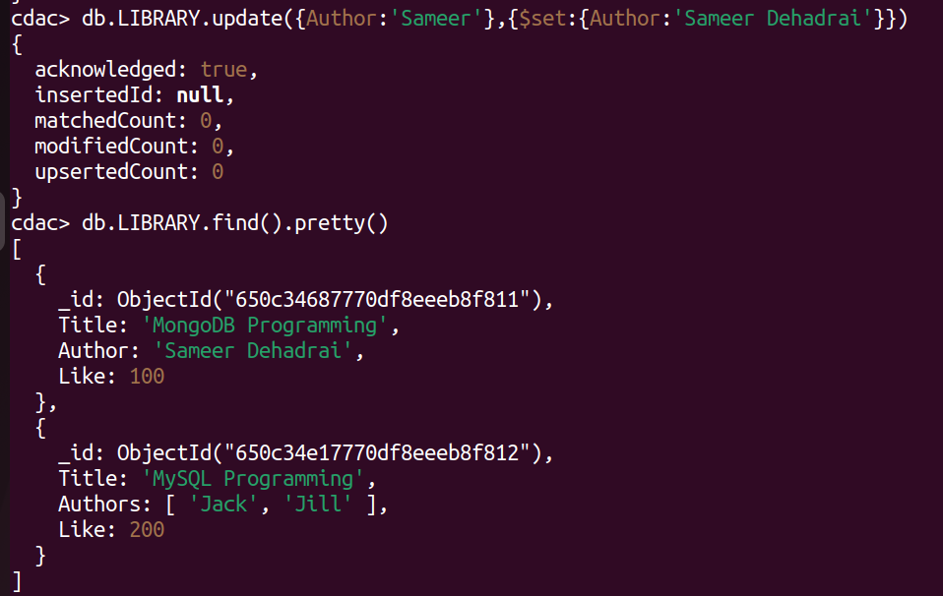

16. Delete all documents that have 100 likes.

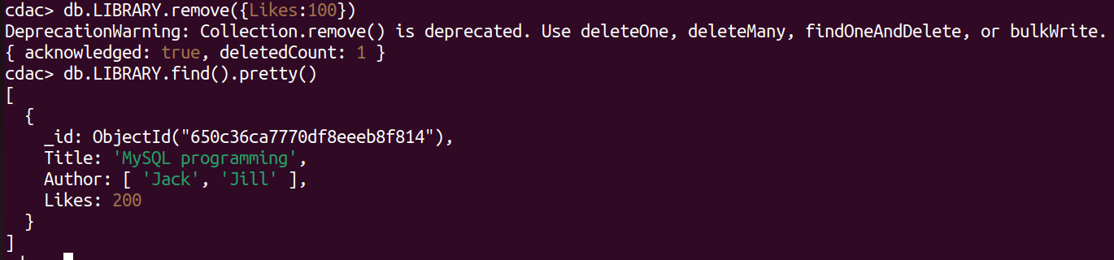
17. Drop the LIBRARY collection.
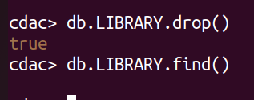

18. Drop the CDAC database
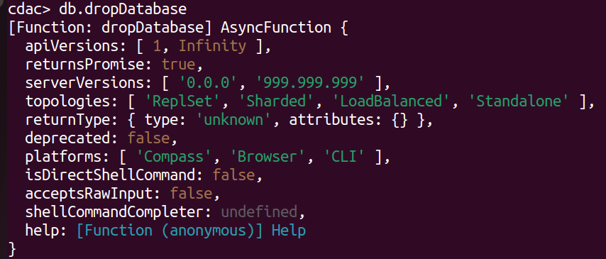
19. Exit from MongoDB shell
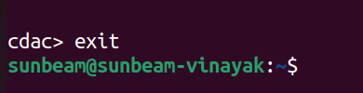

20. Stop MongoDB server
>ctrl + C

