SQL ASSIGNMENT – 10

Joining a table to itself.

Q1) Write a query that produces all pairs of salespeople who are living in the same city. Exclude combinations of salespeople with themselves as well as duplicate rows with the order reversed.
Ans :

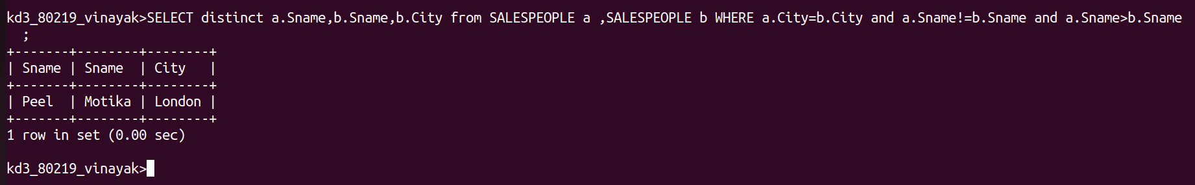

Q2) Write a query that produces the names and cities of all customers with the same rating as Hoffman.

Ans :
