SQL ASSIGNMENTS – 11

Subqueries.

Q1) Write a query that uses a subquery to obtain all orders for the customer named Cisneros. Assume =you do not know his customer number (cnum).

Ans :

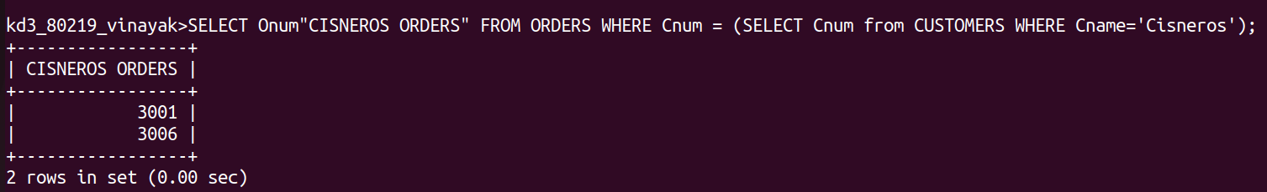

Q2) Write a query that produces the names and ratings of all customers who have above-average
orders.
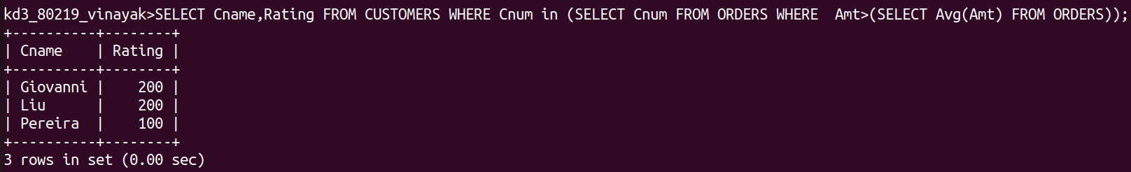
Ans :

Q3) Write a query that selects the total amount in orders for each salesperson for whom this total is greater than the amount of the largest order in the table.

Ans :

