SQL ASSIGNMENT – 12

Using the operators IN, ANY and ALL.

Q1) Write a query that selects all customers whose ratings are equal to or greater than ANY of Serres'.
Ans :

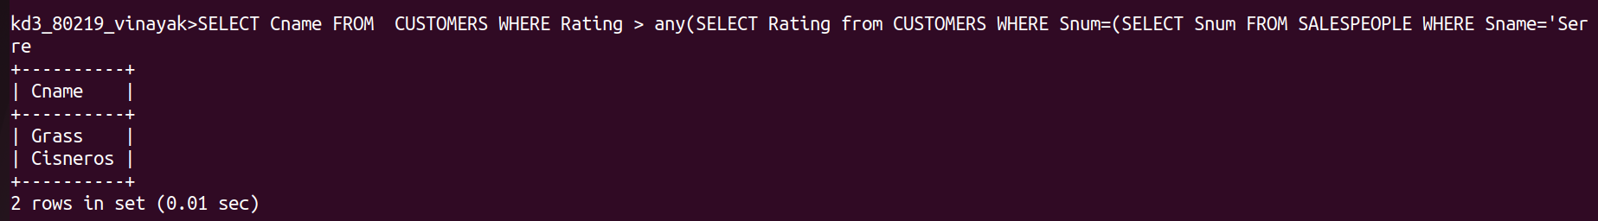

Q2) Write a query using ANY or ALL that will find all salespeople who have no customers located in their city.

Ans :

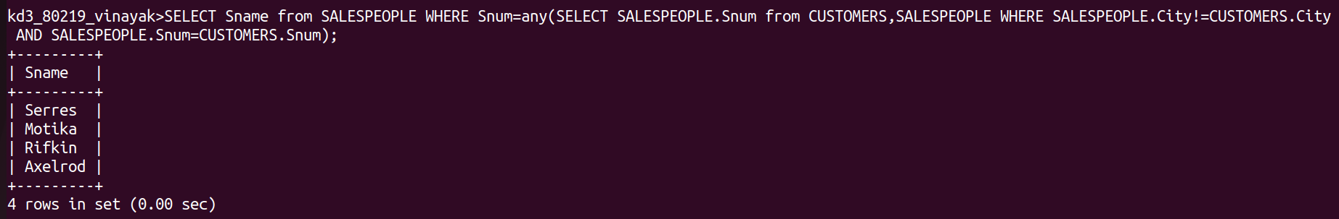

Q3) Write a query that selects all orders for mounts greater than any for the customers in London.
Ans :

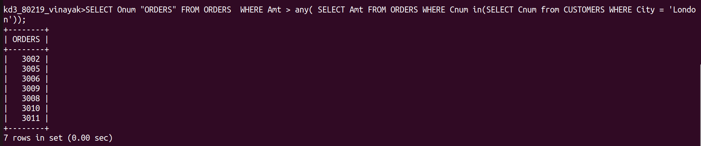

Q4) Write the above query using MIN or MAX.

Ans :

