SQL ASSIGNMENT – 14

Entering, Deleting changing field values .

Q1) Write a command that puts the following values, in their given order, into the salespeople table: city San Jose, name - Blanco, comm - NULL, cnum -1100.

Ans :

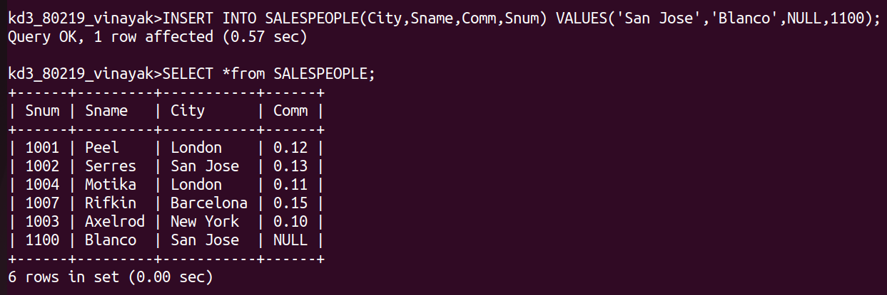

Q2) Write a command that removes all orders from customer Clemens from the Orders table.

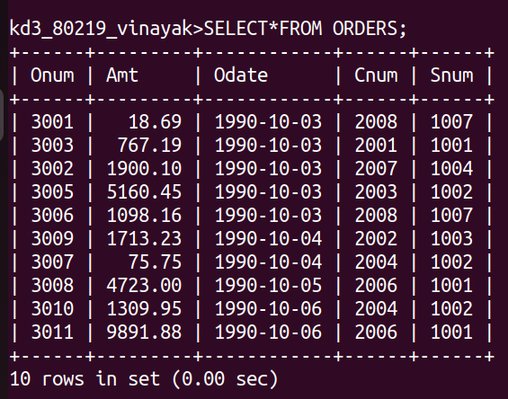
Ans :

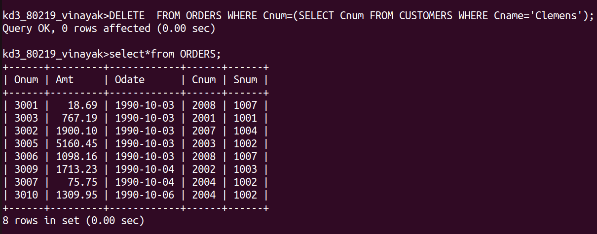

Q3) Write a command that increases the rating of all customers in Rome by 100.
Ans :

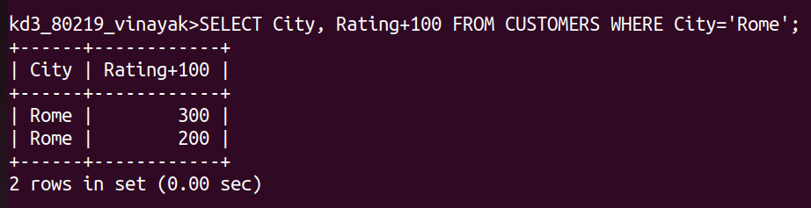

Q4) Salesperson Serres has left the company. Assign her customers to Motika.
Ans :

