SQL ASSIGNMENT – 15

Using Subqueries with DML Commands.

Q1) Assume there is a table called Multicust, with all of the same column definitions as Salespeople. Write a command that inserts all salespeople with ore than one customer into this table.

Ans :

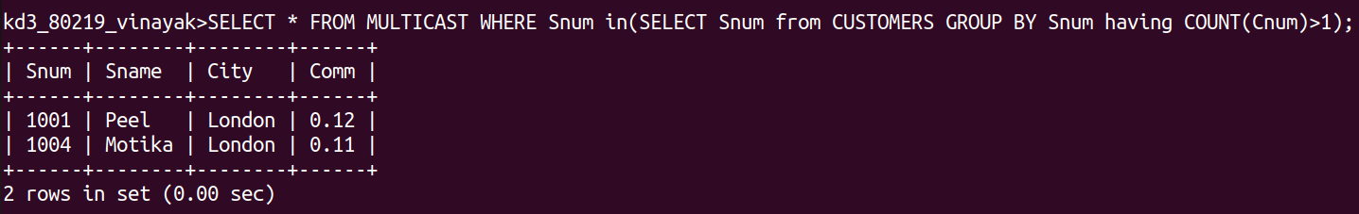

Q2) Write a command that deletes all customers with no current orders.
Ans :
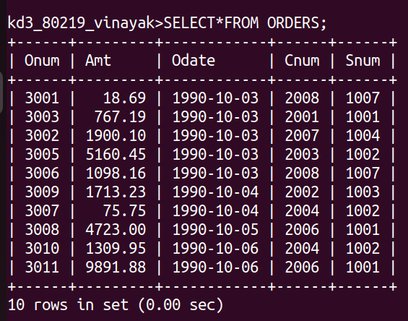

Q3) Write a command that increases by twenty percent the commissions of all salespeople with
total orders above Rs. 3,000.

Ans :
