SQL ASSIGNMENT – 9

Quering multible tables at once.

Q1) Write a query that lists each order number followed by the name of the customer who made the rder.

Ans :
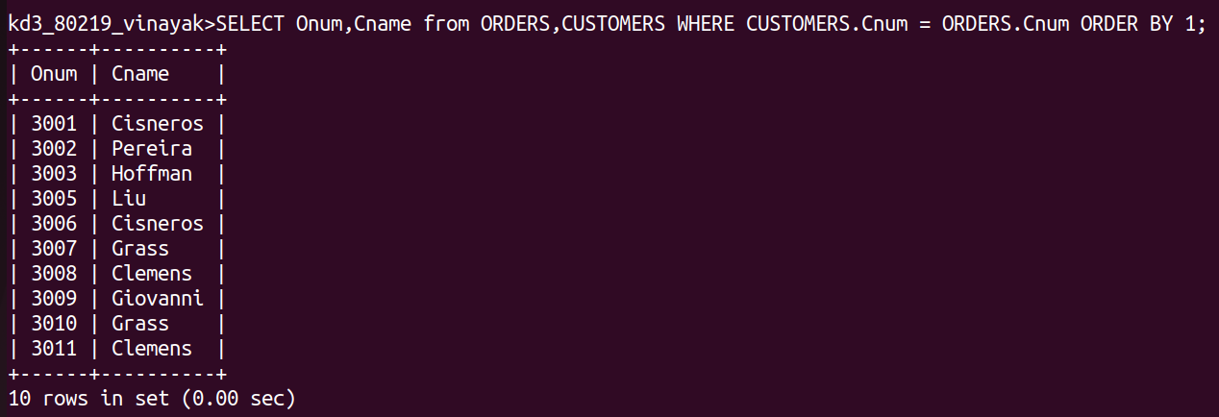

Q2) Write a query that gives the names of both the salesperson and the customer for each order along with the order number.

Ans :
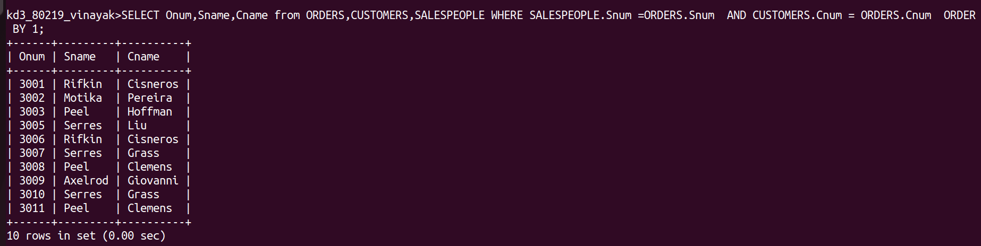

Q3) Write a query that produces all customers serviced by salespeople with a commission above 128. Output the customer's name, the salesperson's name, and the salesperson's rate of commission.
Ans :
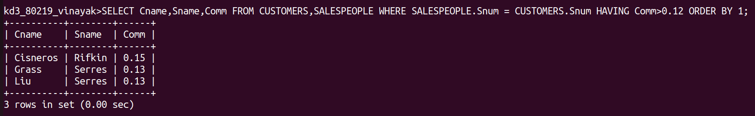

Q4) Write a query that calculates the amount of the salesperson's commission on each order by a
customer with a rating above 100.

Ans :
